**I would like to thank you for giving me opportunity to introduce myself**

**My name is Akshay Dattatray Dhamal I am from Phaltan Maharashtra, I have completed my bachelors of Engi. with 7.7 CGPA From GSM College of Engg Balewadi. and pass out in Nov 2021**

**Then I have Joined Capgemini in 10 May 2022, So they provided me a Java Training after that SmartComm Training.**

**So On the basis of SmartComm Skill  I selected for one project ACG(Migration Project) This mainly Migrate a Templates From OpenText Extreme to SmartComm, So For in this project I have worked from the scratch to create a template, shared Contents (Messages with logic using DXF), layouts, and Styleset.**

**................................................**

**Derived property : Derived property are not directly taken from the transaction input, whereas the other incoming values we can used for the derived property ex. Suppose we have created Age as derived property in BO we can calculate the age based on the values DOB present in the transaction XML.**

**............................................**

* **fop.xconfig file me entry ke badd font folder me font dalna hota hai**

**..............................................**

**Simple Page Master: In page sequence master we will defind the every pages which will consit all sides magin and will define the header, footer and body region based on the requirement, whether i could be portrait or landscape**

**Page Sequence Master : Here we will define on what sequence letter world get printed**

**simple page master (Name ) First any/odd/even**

**simple page master (Name) rest any/odd/even**

**simple page master (Name ) Last any/odd/even**

**Page Sequence : - we can define the region to section mapping which will be visible in template like logo body footer, general info**

**fo:static content fo.table focolumn**

**..............................................**

**OP Config - Job Setup**

**Deliver-> Custom**

**Bin Output: Multiple transaction can be generated in one single file like Ps. with the help of java we can also generated the metadata file with the customized field.**

**Envelope : separate pdf's can be generated in the defined path.(used in ACG)**

**Disk: Thunderhead will generate the direct output put in the path following the default naming conventions**

**SMTP: Used to send outputs in Batches via mail channel.**

**......................................**

**Batch Config(in TH): - Template selector(in SC) –**

**BO, xpath.loadbo( path, recourse ID, Root element)**

**Channel, job.addchannel(channelname, ps,pdf,email)**

**Job Setup, job.setchannelProperty (chanindex, print.jobsetup, xyz(opconfig))**

**template, job.settemplate**

**pass Arguemnt,job.setarg**

**Submit job()**

**password.encrypt.userpw**

**........................................**

**\*\* Introduction \*\***

Thank you for providing me with the opportunity to introduce myself. I'm <**Akshay Dattatray Dhamal**>, residing in <**Phaltan**>. I completed my <**BE**> and commenced my career with <Organisation> through campus placement in <10/May/2022>. After dedicating approximately <**2**> years to <**Capgemini**>,  accumulating over <**1 Year**> of hands-on experience in SmartComm. In my current role, I manage customer communication through various channels such as print, archive, email, and SMS for <Auto Club Group(ACG)>. This involves coordination across seven different regions, including <Regions>.

* SmartComm version : **28.0.4**
* Thunerhead v5.1.5

  Thunderhead content Studio (Advance Template Designer(ATD))   
  
  -------------------------------------------------------------------------------------------  
  Business Object Studio (Data Moduler)  
  Create BO  
  
  First we define the Root Node  (property)  
  Elements:   
  Simple Property : Contains the data type such as number date and string which comes directly from incoming xml  
                text allows to contain any data/ string  
                decimal include the decimal places  
                whole number -2 billion to +2 billion  
                Long Whole number -9 billion to -9 billion  
                Yes/no  
                date  
  
  Enumerated Property : consist of the predefined values, e.g. created a different region in Particular BO  
  
  Derived property : Derived property are not directly taken from the transaction input, whereas the other incoming values we can used for the derived property ex. Suppose we have created Age as derived property in BO we can calculate the age based on the values DOB present in the transaction XML.  
  
  ex:        if(this.gender().equalsIgnoreCase('M')){  
          Return "MAle";  
          else if(this.gender().equalsIgnoreCase('F')){  
          Return "FEMAle";  
          else{  
          Return "unstated";  
          }  
          }  
  
  Object property: To create a instance of  business object class within the same business object resource. It could single or multiple where the object property can be used to create a class in BO.

  -------------------------------------------------------------------------------------------  
  
**Template**  
  Template editions: Enables the various output of document s by the application. Each document template is associated with one or more channel at the point of creation  
  Channels  
  Styleset -  Barcode - fonts - Dynamic Styleset  
  Bo  
  Layout

    **Simple Page Master**: In page sequence master we will define the every pages which will consist all sides margin and will define the header, footer and body region based on the requirement, whether it could be portrait or landscape.  
    **Page Sequence Master** : Here we will define on what sequence letter world get printed  
                 simple page master (Name )   First  any/odd/even  
                 simple page master (Name )   rest   any/odd/even  
                 simple page master (Name )   Last   any/odd/even  
  
    **Page Sequence** : - we can define the region to section mapping which will be visible in template like logo body footer, general info  
            fo:static content fo.table focolumn  
  
  Shared content - Editions - Barcode - Mutipart Table - Mutipart Table - Dynamic Shared content  
  
  Script Library - document script - inline script  
  
  enclosures - Nested enclosure will not work in SmartComm

OP Config -  Job Setup   
        Deliver->Custom  
          Bin Output: Multiple transaction can be generated in one single file like Ps. with the help of java we can also generated the metadata file with the customised field.  
          Envelope : separate pdf's can be generated in the defined path.  
          Disk: Thunderhead will generate the direct output put in the path following the default naming conventions

Batch Config: - Tempalte selector - (Basic Steps to run template)  
        Chaneel, job.addchannel(channelname, ps,pdf,email)  
        Job Setup, job.setchanneljobproperty (chanindex, print.jobsetup, xyz(opconfig))  
        template, job.settemplate  
        BO, xpath.loadbo  
        pass Arguemnt,job.setarg  
        Sumit job()

Custom Handler: pdf renaming, Metadata

Admin - Not presenent in smartcomm  
    Director Listner Create  
    User Rights  
    Project Import/Export  
    Update the Batch config and Op Config,  
    Craete new Channels  
    Project roll back

THDashboard - Transaction Report

Diagnostics - default Email and SMTP Address defined

**Draft Editor** - Can be used to generate the customised transaction by the customer care /Agent, Some of the fragments edited based on the required customer information and some of the can be edited like company information, premium information.  
  
1.1.1  
Release.Major.minor

**Asemby rule** **:**  
IF WHEN and FOR for each

**AGILE** --> REQUIRMENT->DESIGN->DEVELOPMENT->TESTING->Maintainance / Highlevel requirment where  the requiment will gather by the dev team / Sprint based or phase wise , next sprit //continous feedback /phases

**WALTERFALL** --> REQUIRMENT->DESIGN->DEVELOPMENT->TESTING->MAINTAINANCE where the new requirement will we need to start from the scratch/ fixed time and fixed cost

**Performance Testing**: 400 letter would get generated in which time period/1 letter how much time it takes.

Maximum no of PS file hold

sort based

pdf password and email password- password.encrypt.userpw  
set local language email link email sent  
on-demand and batch   
interactive pdf  
choice list  
What is Writtent/WriteText/  
How many ways we can pass the logo --> layout and shared content  
Blank page how to remove from  
Language used in derived property  
watermark background-image set as url://  
Name of the property define to print logo from layout (@setproperty([@name=""]/@value=true)

to be continued-->

Two different kind of BO -->  Schema and DTD

---------------------------------------------------------------------------------------------------------------------------------------------------------

var effectivedate = createdate(2021, 3, 21)  
content needs to be printed in between date --> dateafterequales, datebeforeequals --> dateafterequales(BO ELEMENT, effectivedate)  isonafter  isonbefore

---------------------------------------------------------------------------------------------------------------------------------------------------------

two column layout

Managerial   
Stress -   
  
Thunderhead also known as (Advance template designer) Interview Questions

1. Explain Thunderhead/SmartComm end-to-end process.  
2. What is document script and script library  
3. Dynamic URL linking  
4. Multiple Styleset in template  
5. How to install font in sc/thunderhead  
6. Name all the Properties we use in business Object/data modular and explain one by one  
7. Step for batch config to run a end to end transaction  
8. Property  to set password.encrypt.userpw  
9. Opconfig Deliver methods -> Bin(multiple in one), Envolop(single traction), Disk  
10. Explain the step for layout creation  
11. Whats is the difference between batch and on demand  
12. How many ways we can pass the logo --> layout (background-image set as url://) and shared content  
13. Nested enclosures  work in sc/thunderhead? No  
14. How to apply editions  
15. Which language we can use in derived property  
16. editions  
17. How we can supress regions in layout

**WaterMark:**

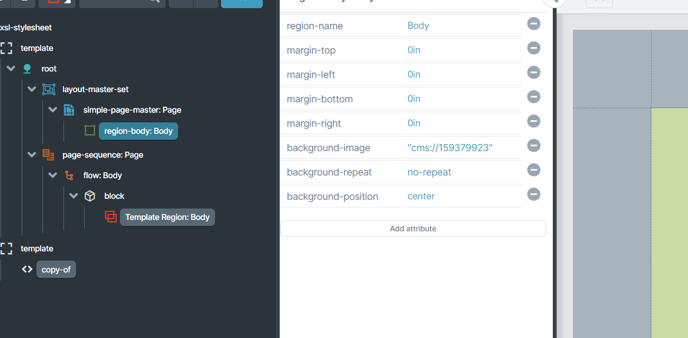

**Image property:**

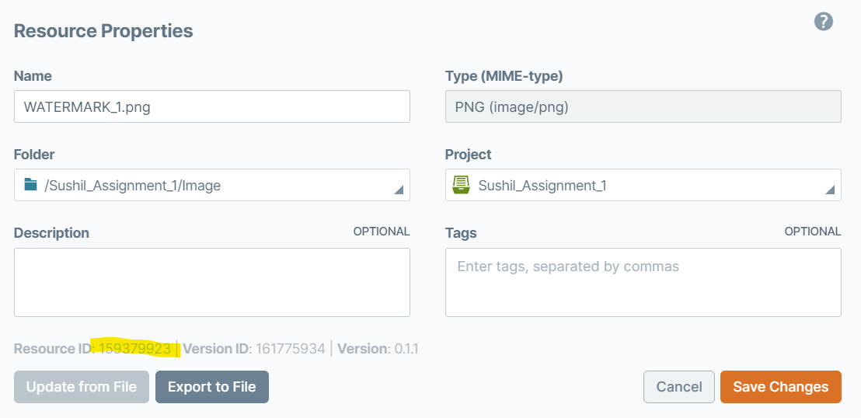

1. **What is Thunderhead/Smartcomm?**

**ANS:** Enterprise Content Management (ECM) is the technologies, tools, strategies, and methods used to capture, manage, store, preserve, and deliver content and documents related to organizational processes across an enterprise.

**More details**: SmartCOMM is a highly configurable and feature-rich cloud native application that has been designed and deployed as a multi-tenant SaaS or hybrid-cloud customer communications solution. It has been built on the AWS EC2 platform to leverage its industry-leading security, high-availability, and elastic scaling features.

* The solution enables non-technical users
  + - * to take control of the creation and maintenance of sophisticated customer communications,
      * empowering organizations to be more agile,
      * quick-to-market and less dependent on IT resources.

It’s intuitive web-design enables business users to create or apply all the building blocks of a communication, including branding, content, references to data items, business assembly rules and adding multiple channels.

1. **Communication Channel Information.**

**ANS:** SmartCOMM is inherently a multi-channel solution. It is designed to be future proofed to support both existing and future communication formats, channels, and platforms.

Existing channel includes:

* + - * Print - including Adobe PostScript, IBM AFP, PDF and Interactive PDF
      * Web and Digital - including HTML, Email, SMS, Social output including WhatsApp
      * Images - including TIFF
      * Other channel output including Fax, Microsoft PowerPoint
      * XML-based output and variations including WordML, ExcelML and VoiceML
      * Social Twitter, Facebook and WhatsApp via Twilio, and any channel that supports REST API and XML
      * Live chat / chatbot any channel that support XML

1. **What is the Batch?**

**ANS:** SmartCOMM’s batch capabilities allow the production of high volumes of communications, typically in an end-of-month / end-of-year processing scenario such as bank statements. SmartCOMM’s unique batch architecture allows organisations to elastically scale up resources to meet peak demands and mission-critical batch windows for these large batches of communications.

– a significant benefit over traditional legacy on premise or managed service offerings in the market, which require pre-provisioning of hardware or managed service capacity to account for peak volumes yet would otherwise sit idle.

1. **On demand means?**

**ANS:**  With the on-demand use case, a single communication is generated in response to an incoming request. An example of this would be the generation of a PDF quote at the end of a web application for a home loan. Requests are simply issued to the SmartCOMM API and a completed communication is returned in the response, making for fluid integration with third-party applications, creating a clean, loosely coupled architecture

Several validated integrations exist between SmartCOMM and 3rd party customer management systems including.

* Guidewire Insurance Suite®, Velocity (Salesforce Industries),
* Pega and Salesforce Sales,
* Health and Financial Service Clouds.

1. **Interactive Feature Means?**

**ANS:** During customer engagement, customer-facing staff – either in a contact center, branch, or in-store environment – need to customise or interact with the communication, before finalisation, making the communication more relevant and personalised.

SmartCOMM gives these agents and/or other authorised users the ability to collect specific information in real time, place it within communications and then further personalise draft communications with approved shared content as well as direct user input before delivering to the channel of their choice.

SmartCOMM has a range of deployment configurations that can be broadly divided into two categories

* + - * Pure Cloud and
      * Hybrid Cloud /Colo model

Both are serviced from AWS. The appropriate option for a specific customer is typically dependent on an organisation’s requirements for data residency.

**Pure Cloud**

The pure cloud approach is suited for organisations that want to host all their server-side operations in the cloud.

**Hybrid/Colo Cloud**

This option leverages the use of a software virtual appliance which is connected to the SmartCOMM tenancy. Our hybrid-cloud option is designed for the needs of organisations that want to benefit from cloud template design and testing but have stricter sensitivity or regulatory oversight over the residency of the customer data used to personalise the communications that are generated.

1. **Generation Process and API’s?**

**ANS**: **Generation Process:**

SmartCOMM communications generation process consumes business data from external sources and then applies business logic, customer profile information and channel-aware processing to assemble graphically rich, highly variable multiple channel business communications.

For on-demand, interactive and batch use cases, the process starts by receiving transactional data as

* XML or JSON input from an external source

SmartCOMM generates multiple channels from a single communication request

|  |  |
| --- | --- |
| **Area** | **Description** |
| **Assembly API** | Generates a draft or a multi-channel communication |
| **Content Management System (CMS) API** | Manipulates resources in the CMS |
| **Correspondence API** | Methods optionally used to interrogate a template ahead of generation |
| **Data Capture Component** | A control that can be embedded within a web page. The page is used to capture data that is required by the template. After the data is captured, the XML data can be used with the Assembly API to generate a multi-channel communication. |
| **Data Capture API** | A collection of RESTful web services that interrogate a template to determine which fields are required to generate a communication. |
| **Bulk API** | A collection of RESTful web services that allow generation job requests to be submitted and managed. |
| **Draft Editor Component** | A control that can be embedded within a web page. The control allows interactive editing of a draft communication by the end-user. The control is typically populated with a draft that is generated via the Assembly API. |
| **User Management API** | A collection of RESTful web services that can be used to administer users and groups |
|  |  |

1. **Difference between Smartcomm and Thunderhead?**

**ANS:**

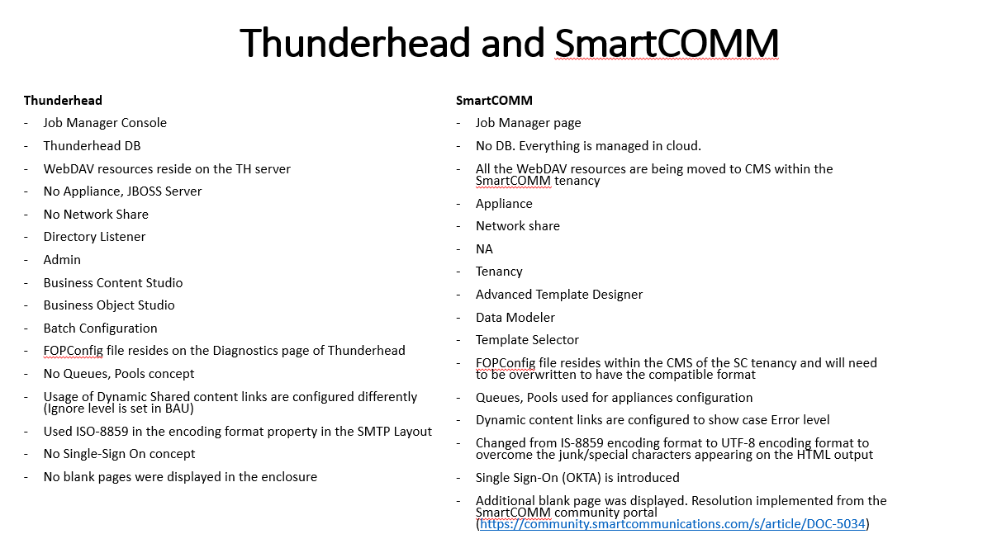

**Qa deployment:**

1. **Home Dasboard > Export**

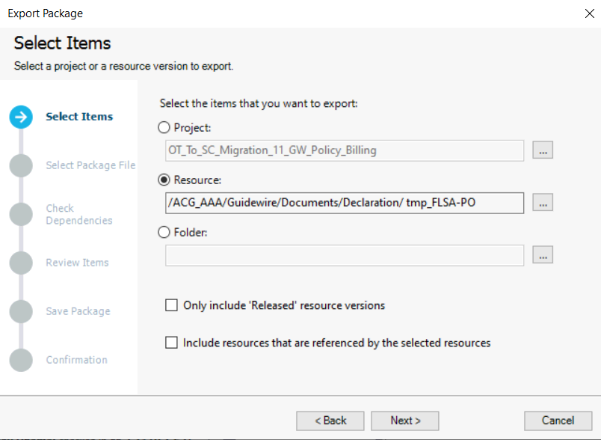

**What things required to create a template?**

Business Object, channels, corresponding layout, Styleset

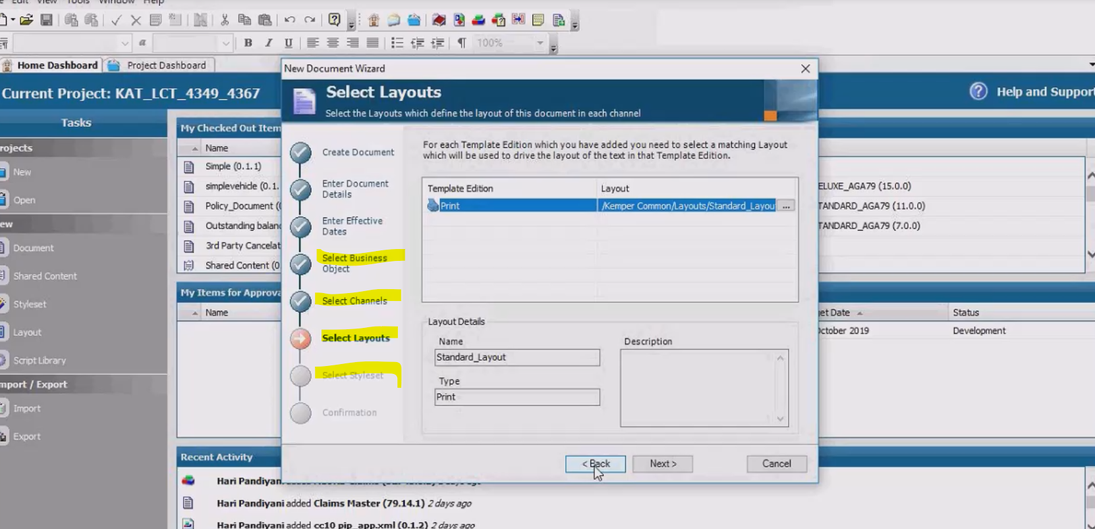

**Scriptable batch config?**

I input will trigger multiple channels we can generate in SBC

**Multiple channel for single template it is possible**

**While previewing a template how it trigger?**

1. Input XML is exactly same as Business Object(Validation)
2. Batch config:- It is guide to ATD like which template need to select/inject not only template with corresponding layout, Styleset, shared contents and all resources to generate a output then finally document goes to rendering process to generate a Template.

**CMS** :- Basically a Repository of all resources(templates, layouts, Stylesets, data moduler etc). We are creating folder structure like billing, notices, policy docs

**Styleset**: Edition and style to be add

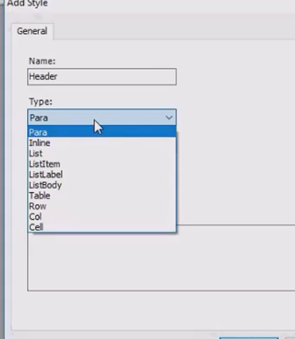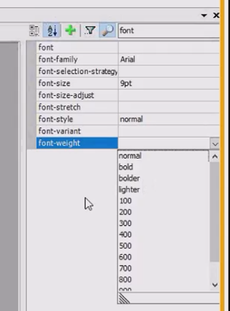Styles types

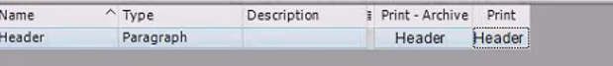

Edition is nothing but a channels we have to select

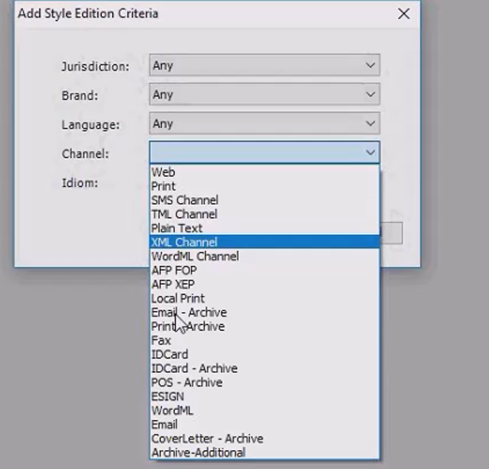

We can add no. of editions/channels to the one style name

**Layout:**

For print and archive Standard A4/letter layout, for web web layout and for Email/sms then Email/sms Layout

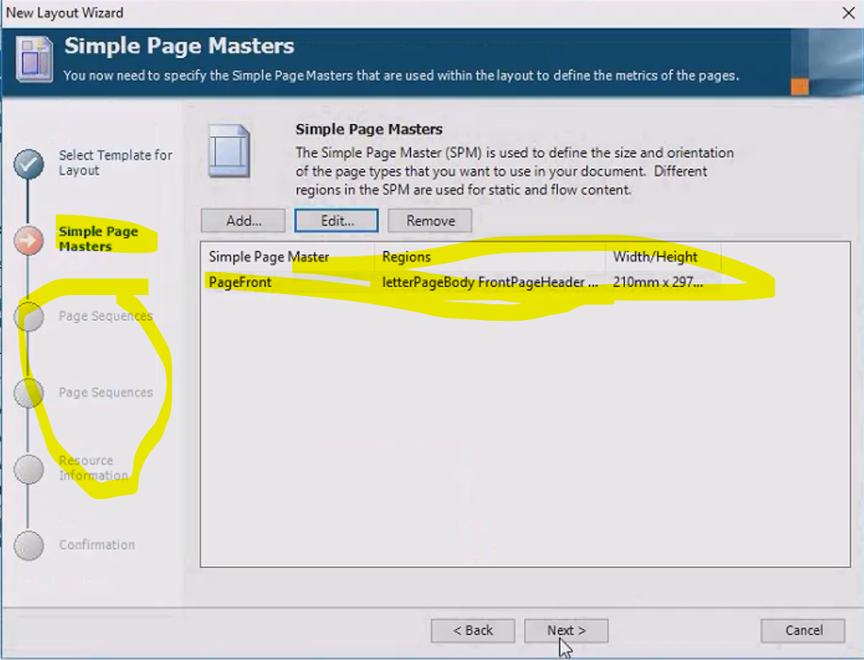

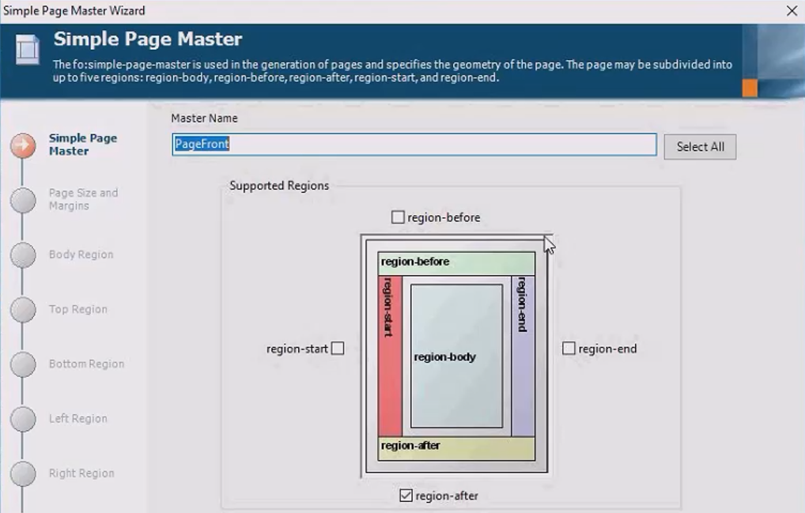

**Page Sequence Master:-** it helps to create 3 layouts of sequence according to one pdf, we need to create a clone of simple page masters with different names like a 3 different layouts

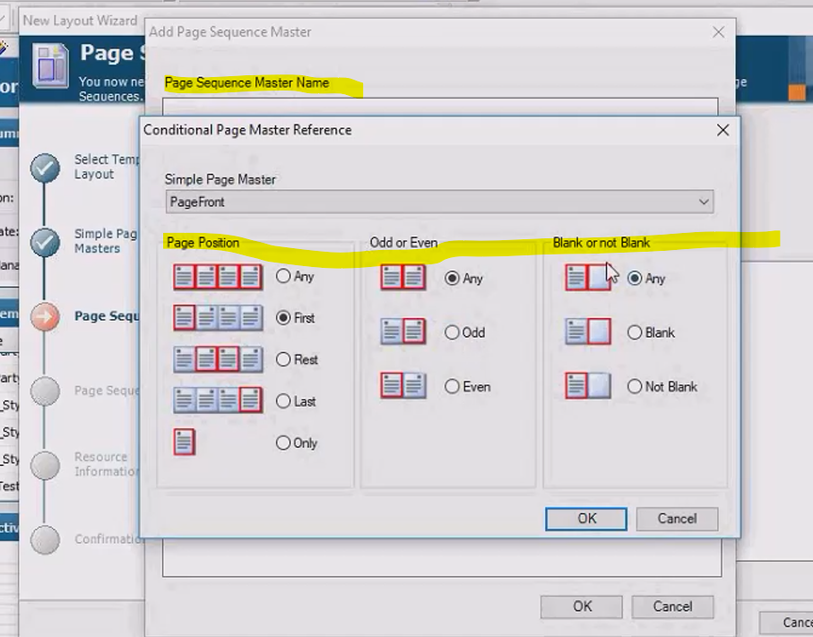

**Multi Part Table:**

Table Collapsed Border style

<fo:retrieve-table-marker xmlns:fo="http://www.w3.org/1999/XSL/Format" retrieve-class-name="ContinuedMarker" retrieve-boundary-within-table="table" retrieve-position-within-table="last-starting"/>

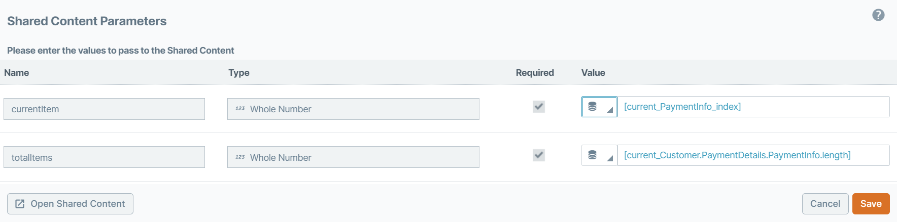

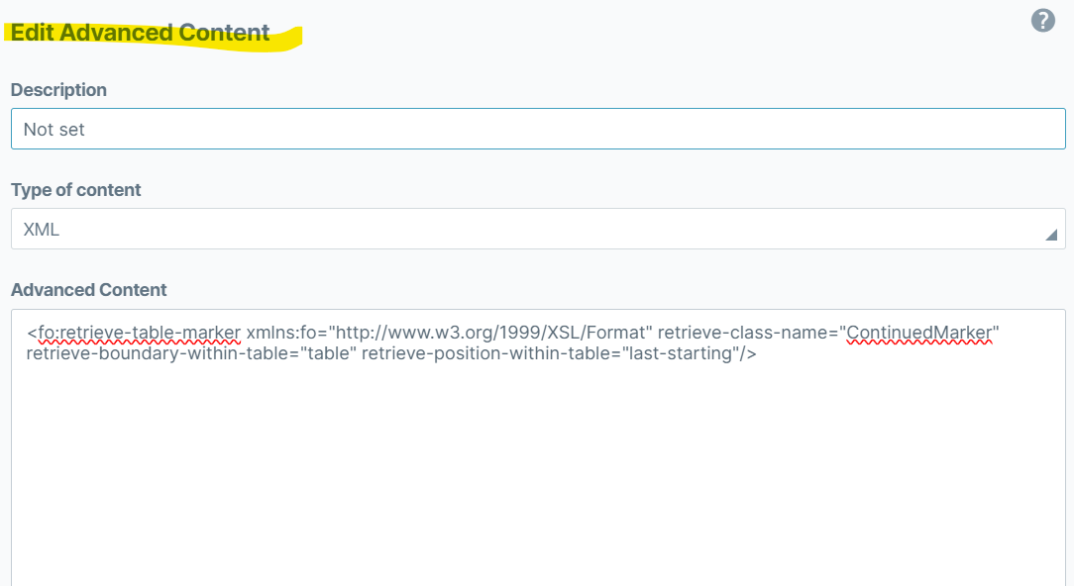

**Functions:**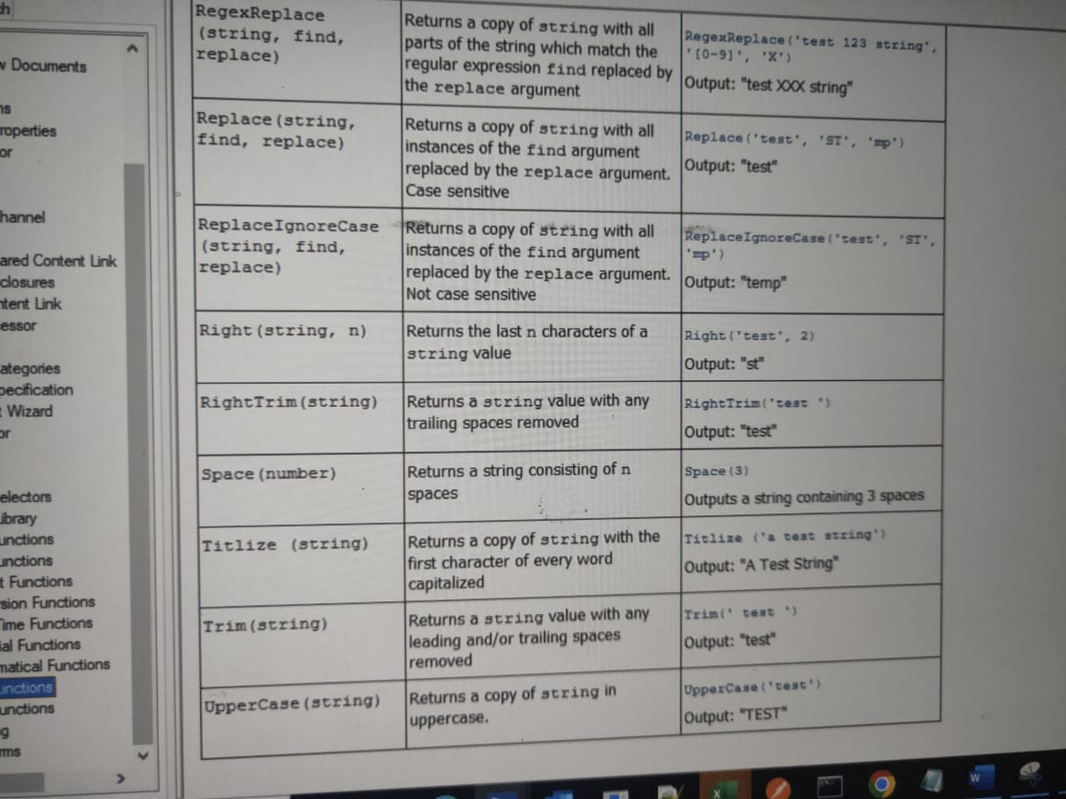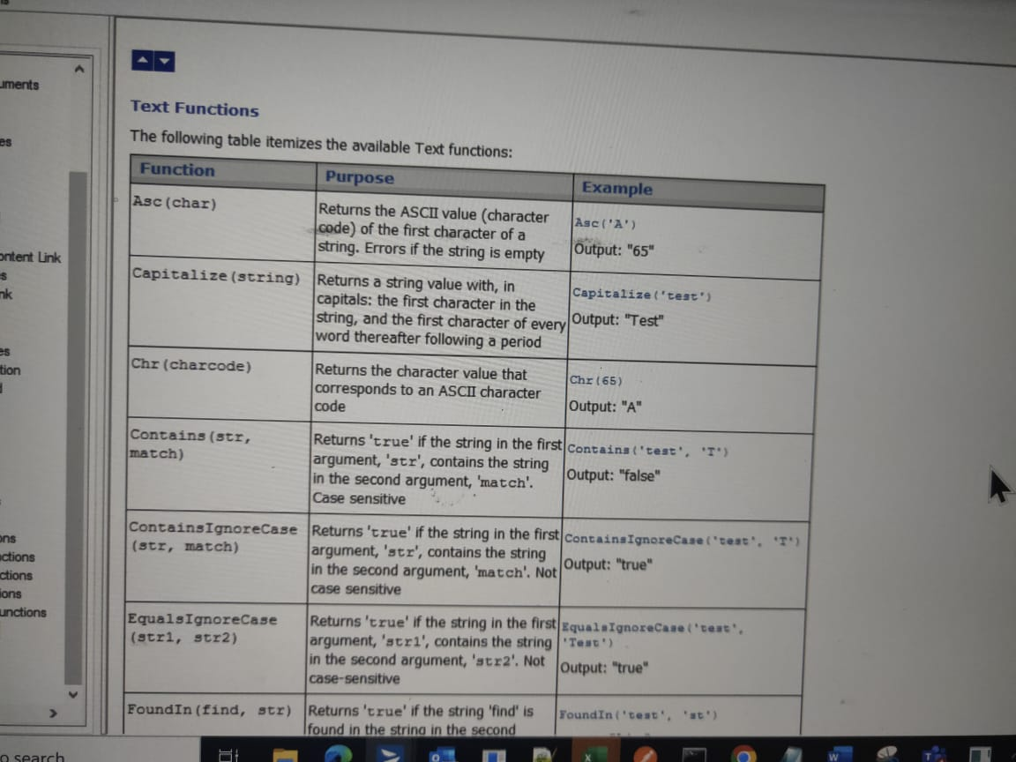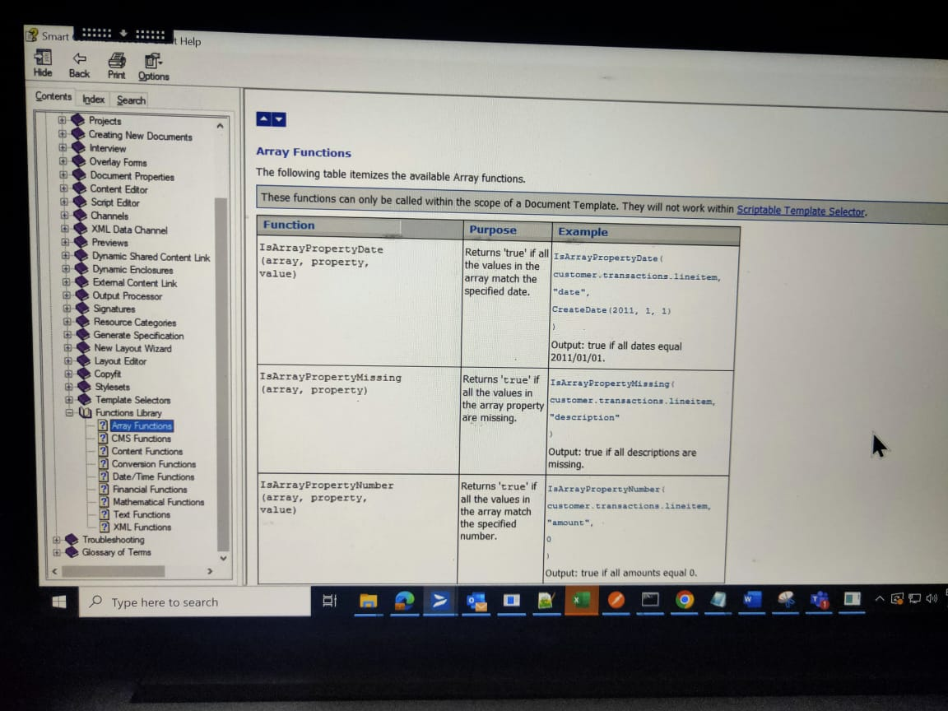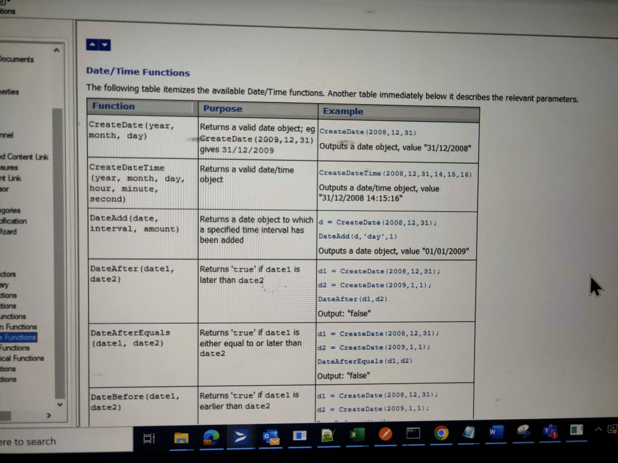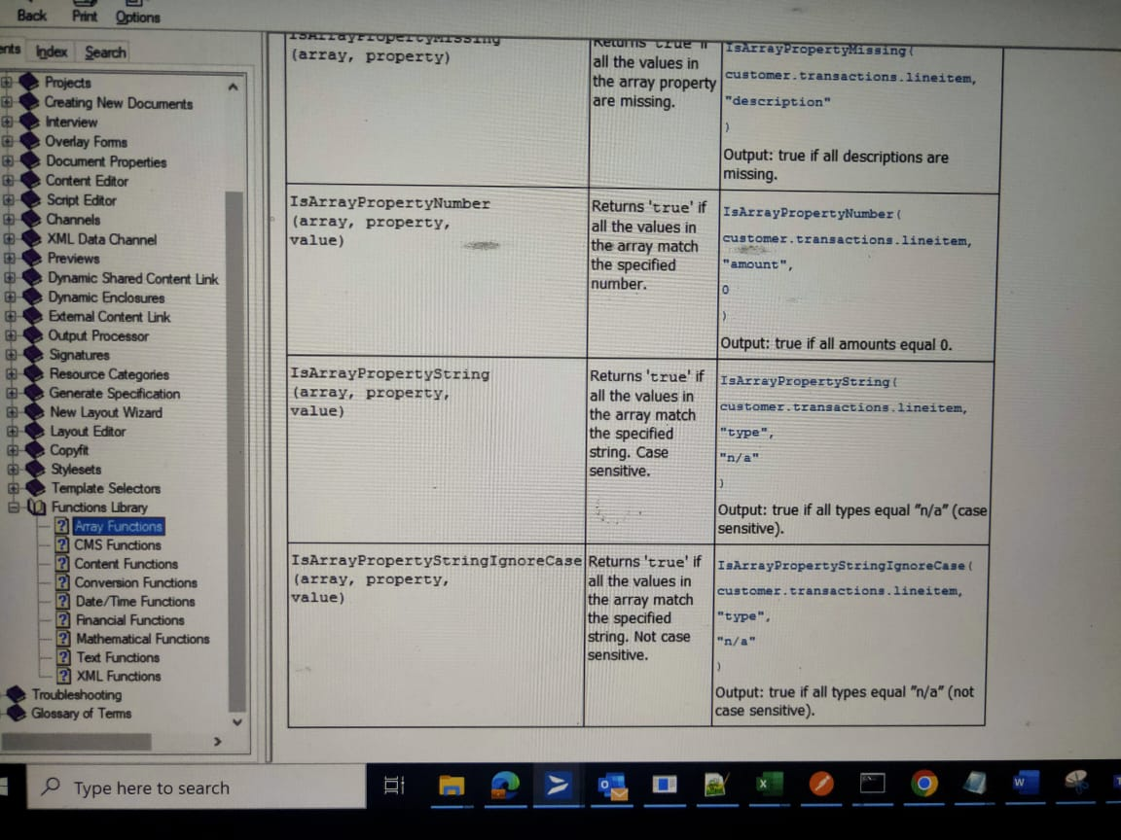

**\*\* Template Selector:**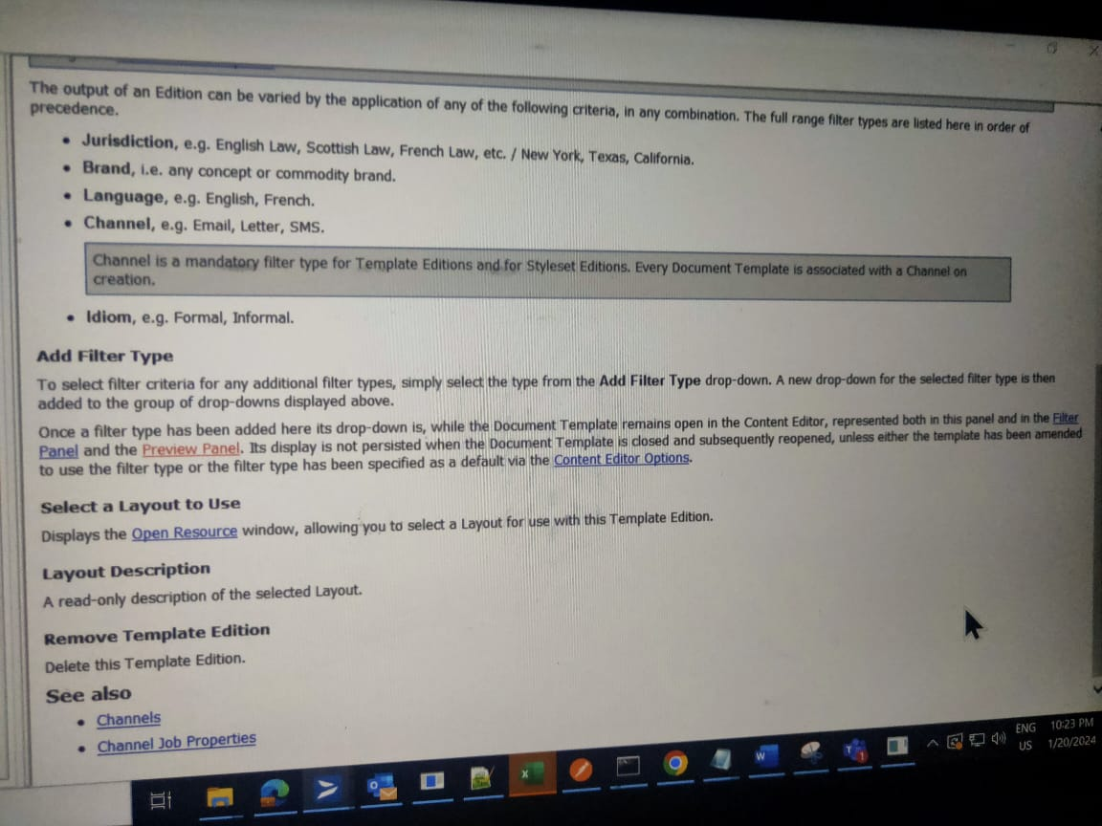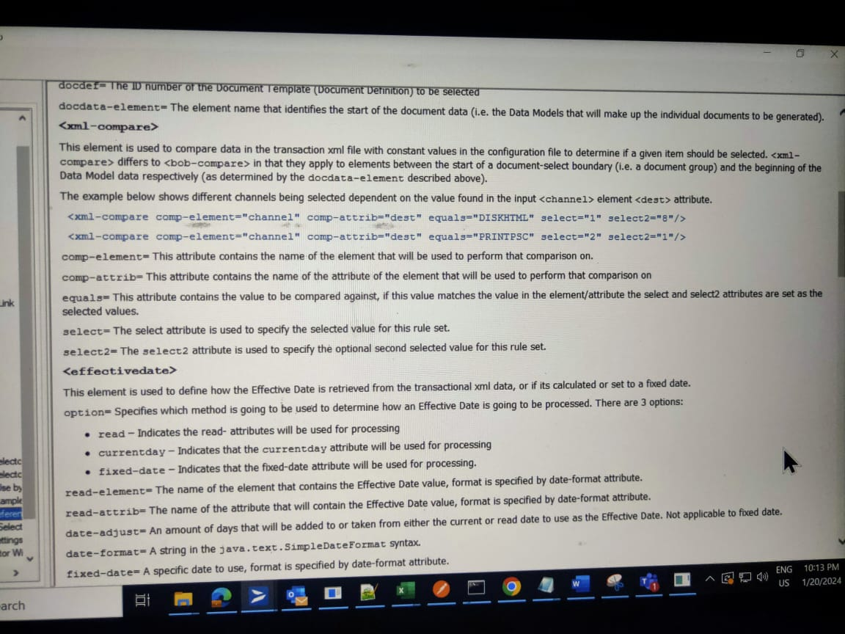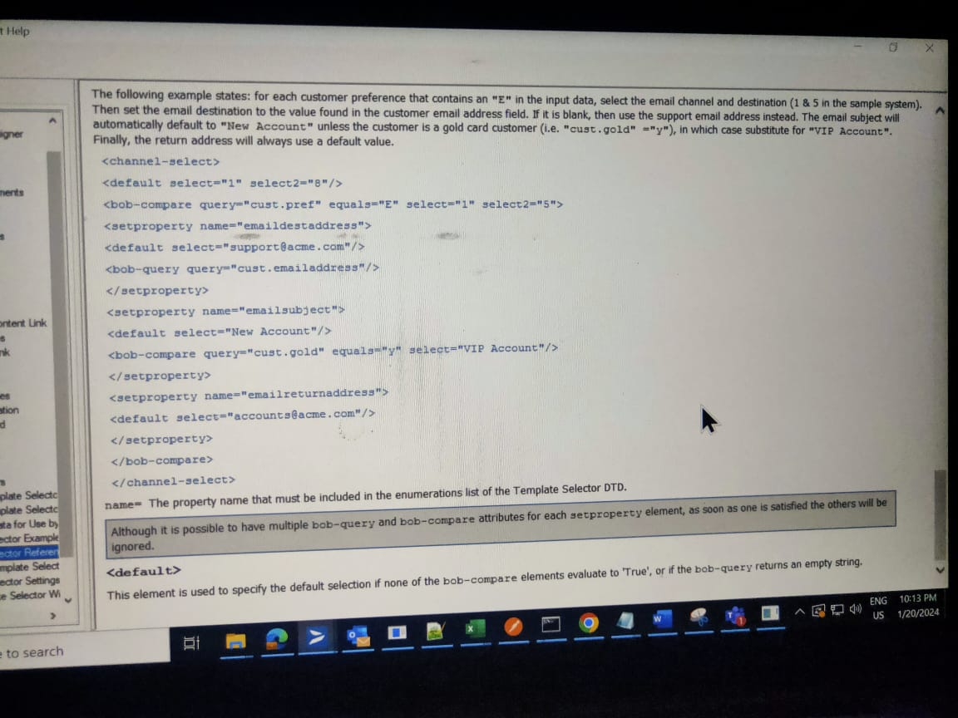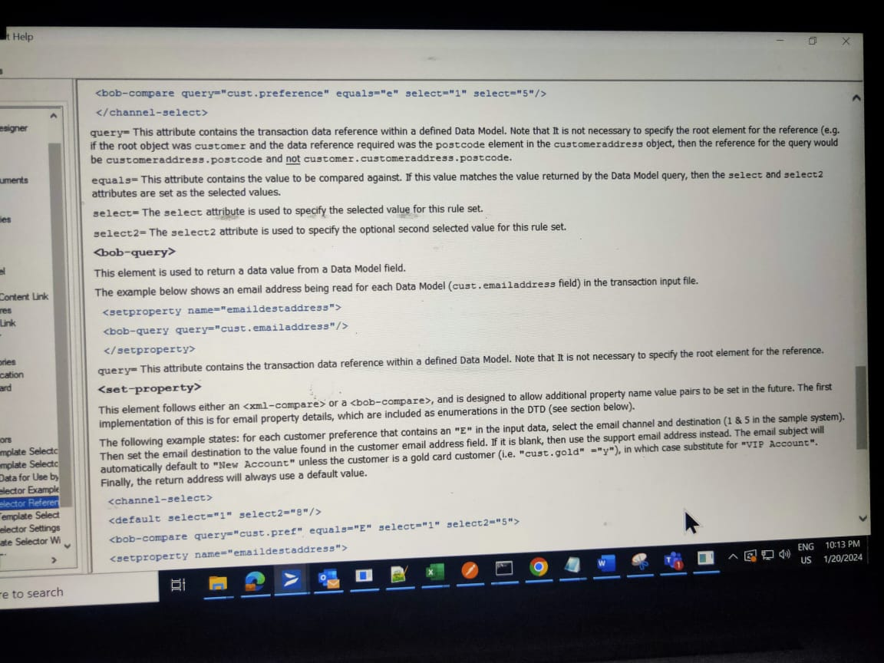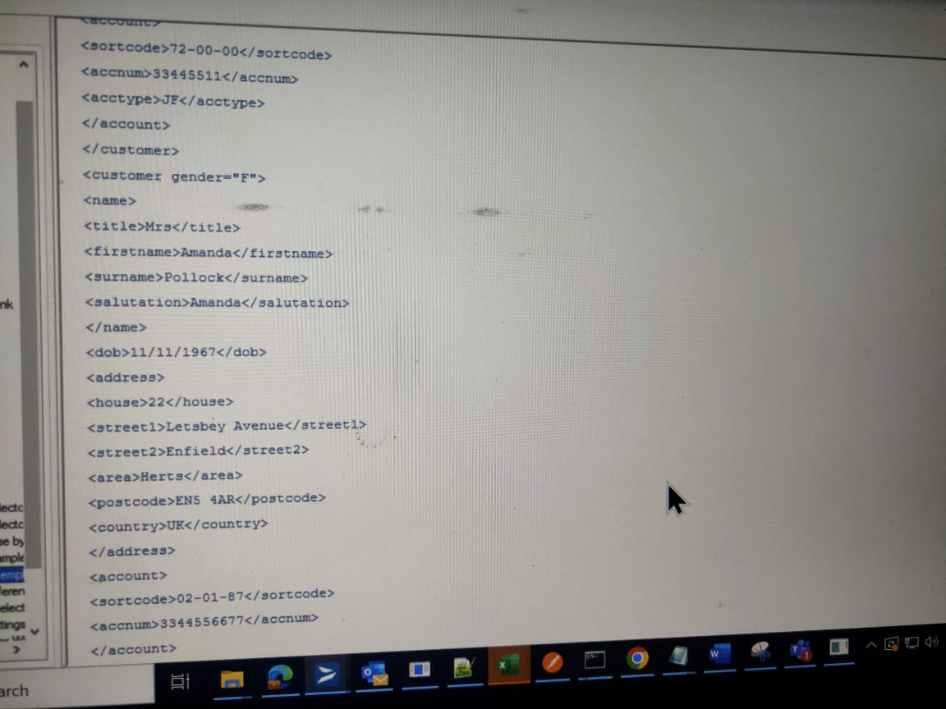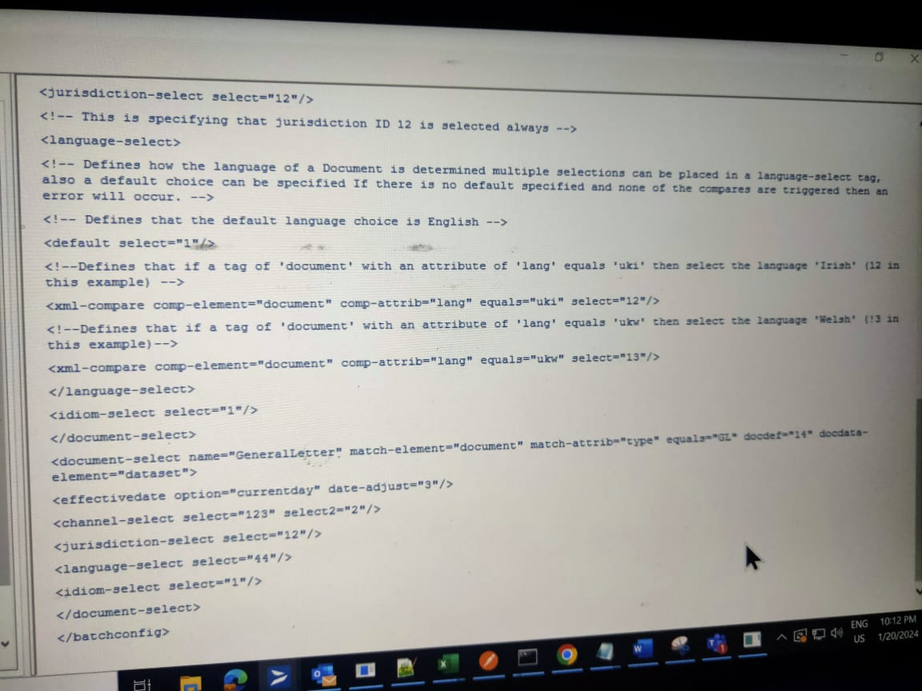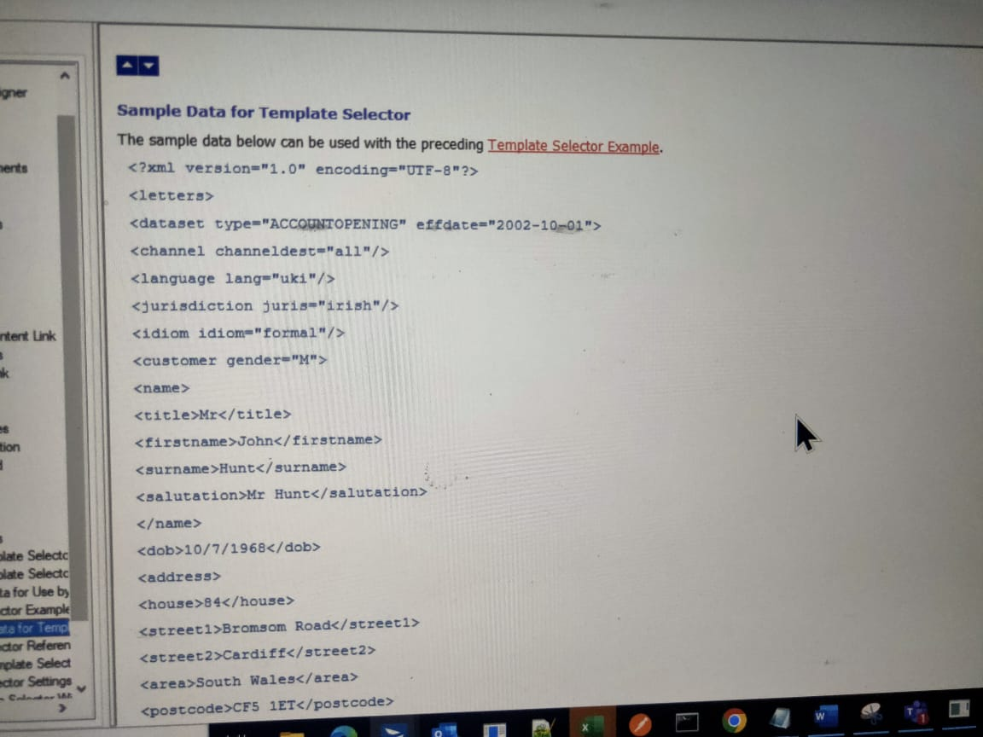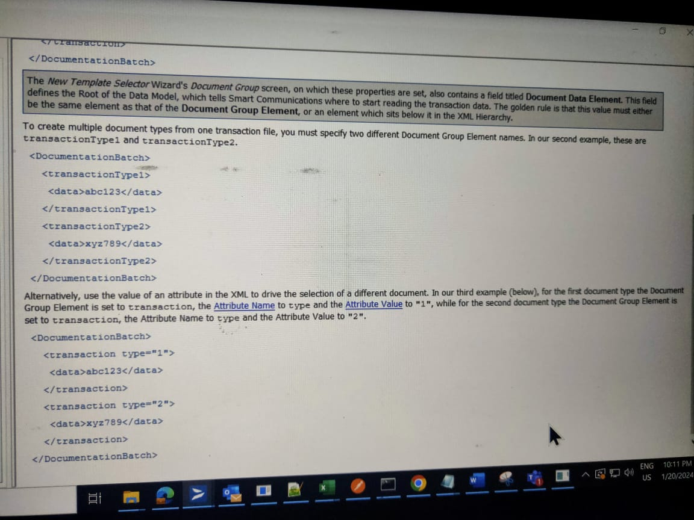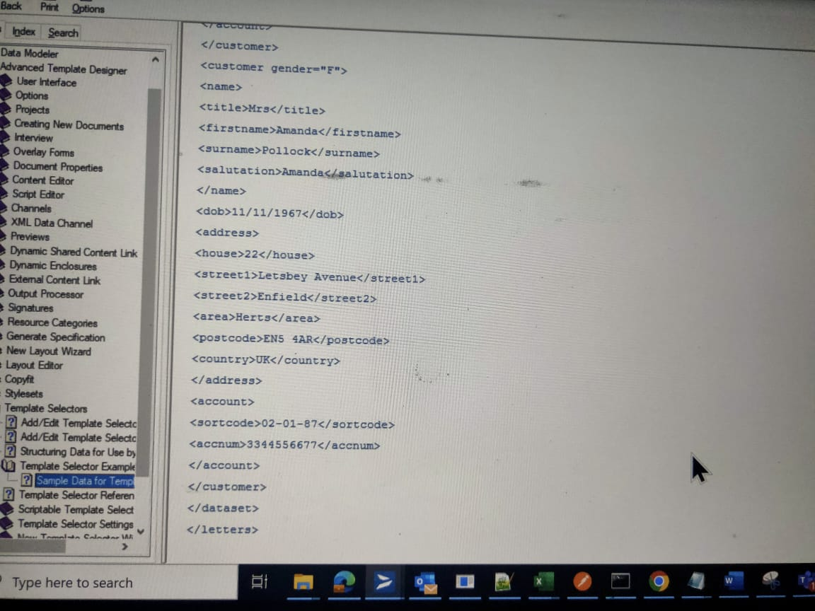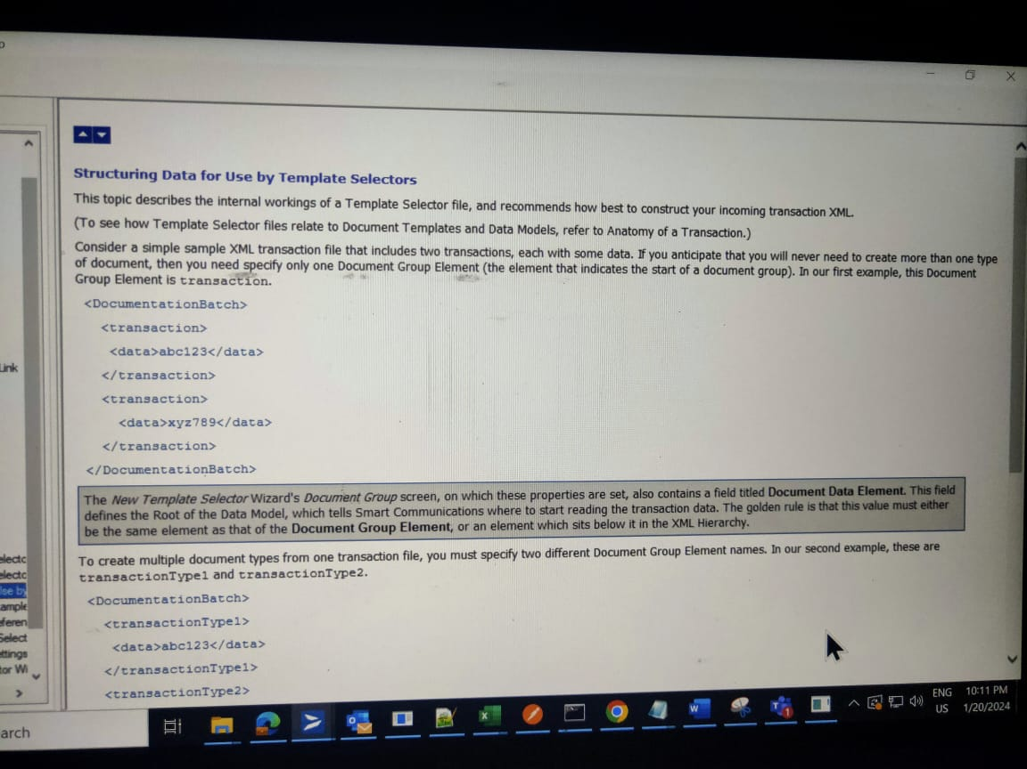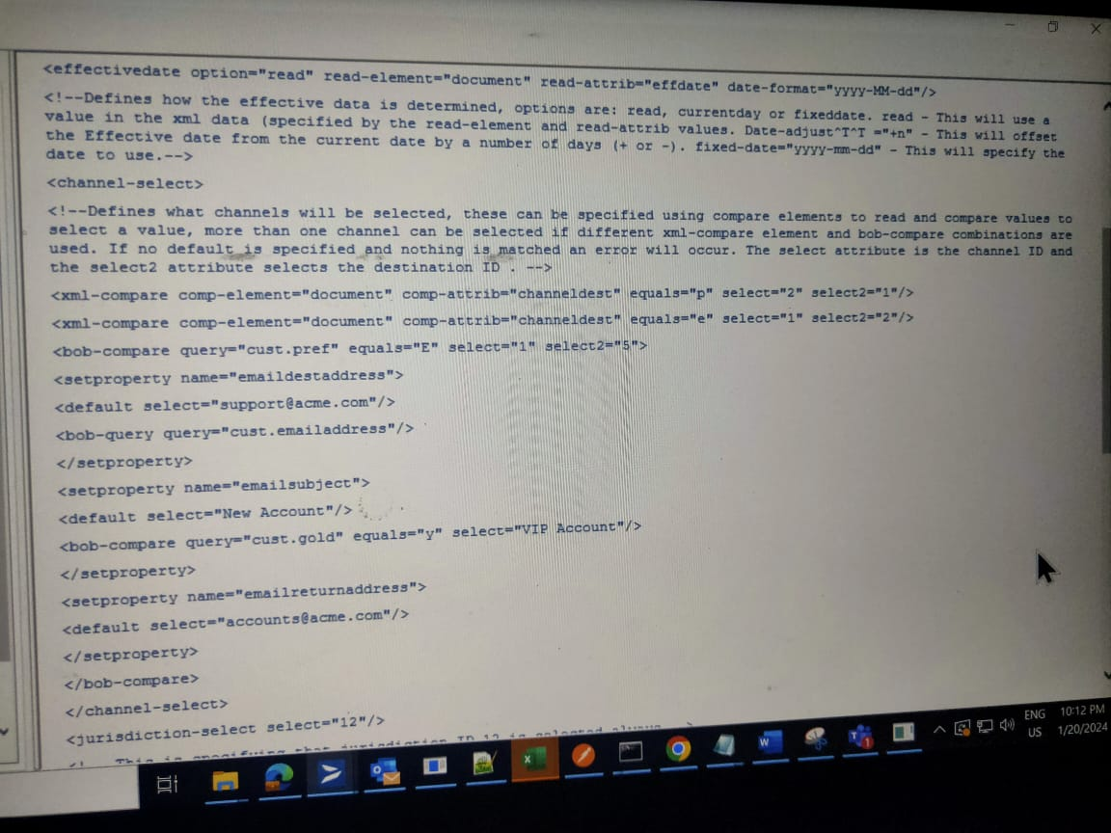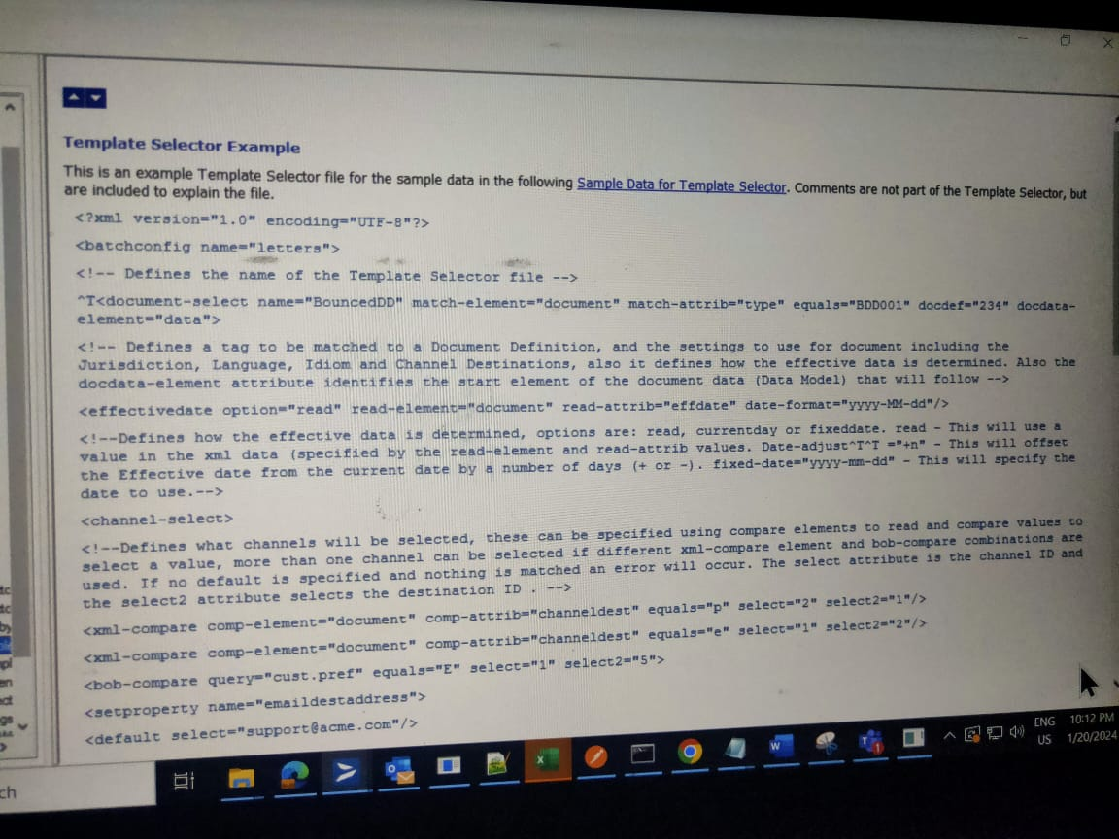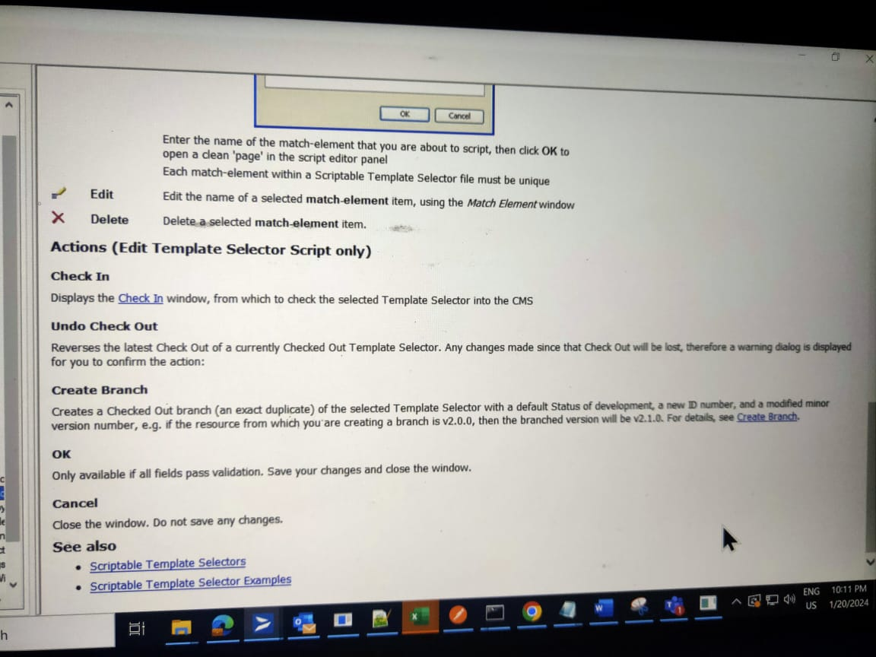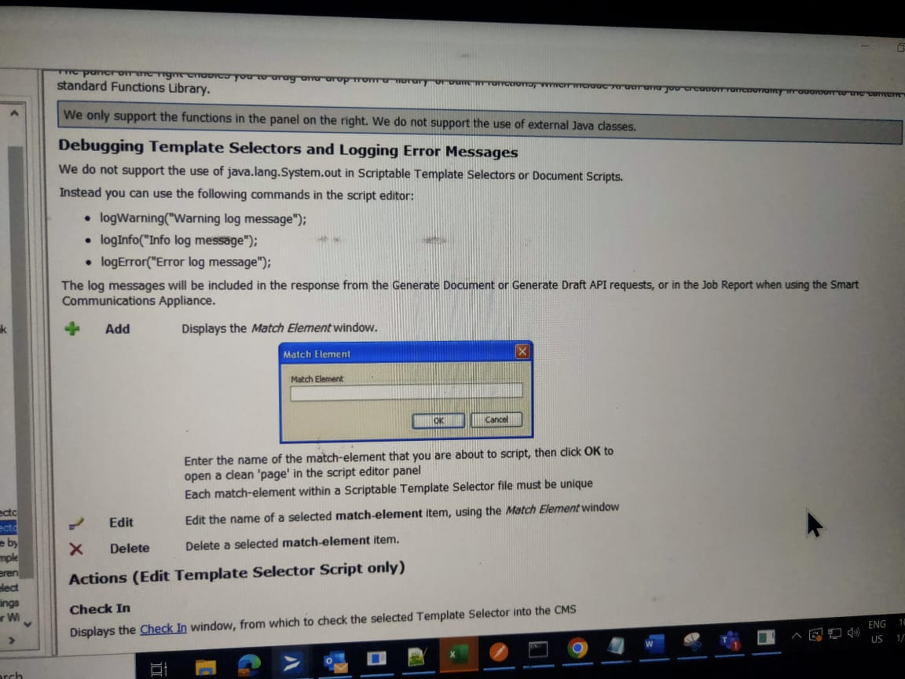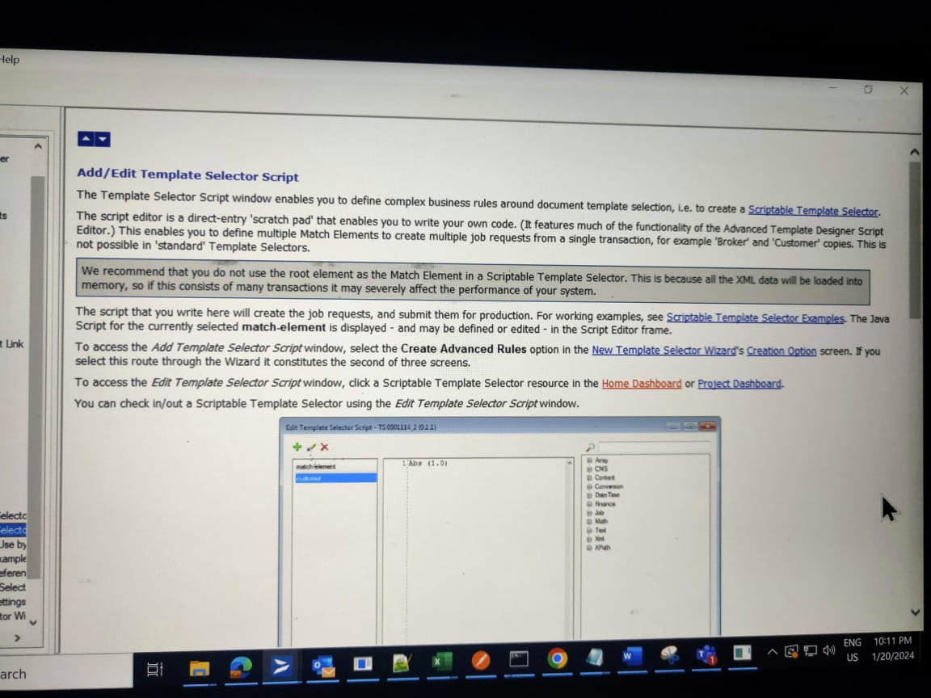

**Job Setup:**

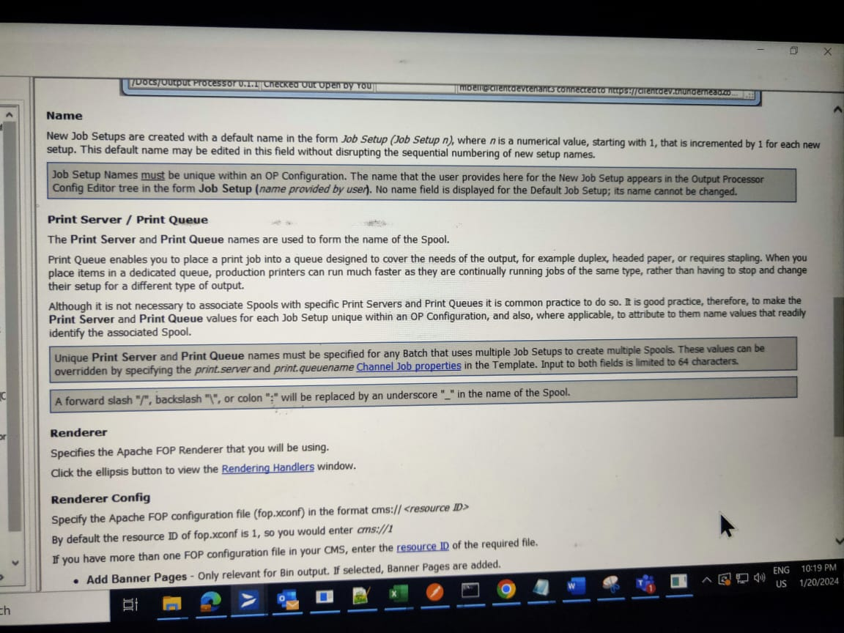

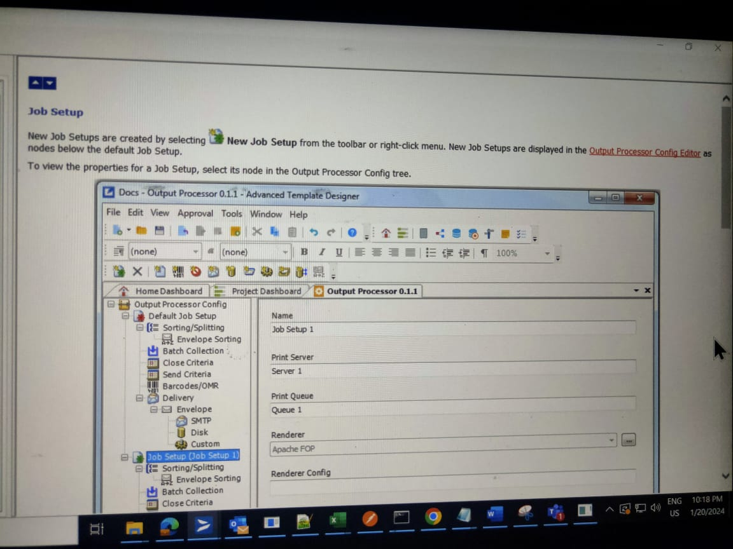

**Enclosure and Shared Content Dynamic:**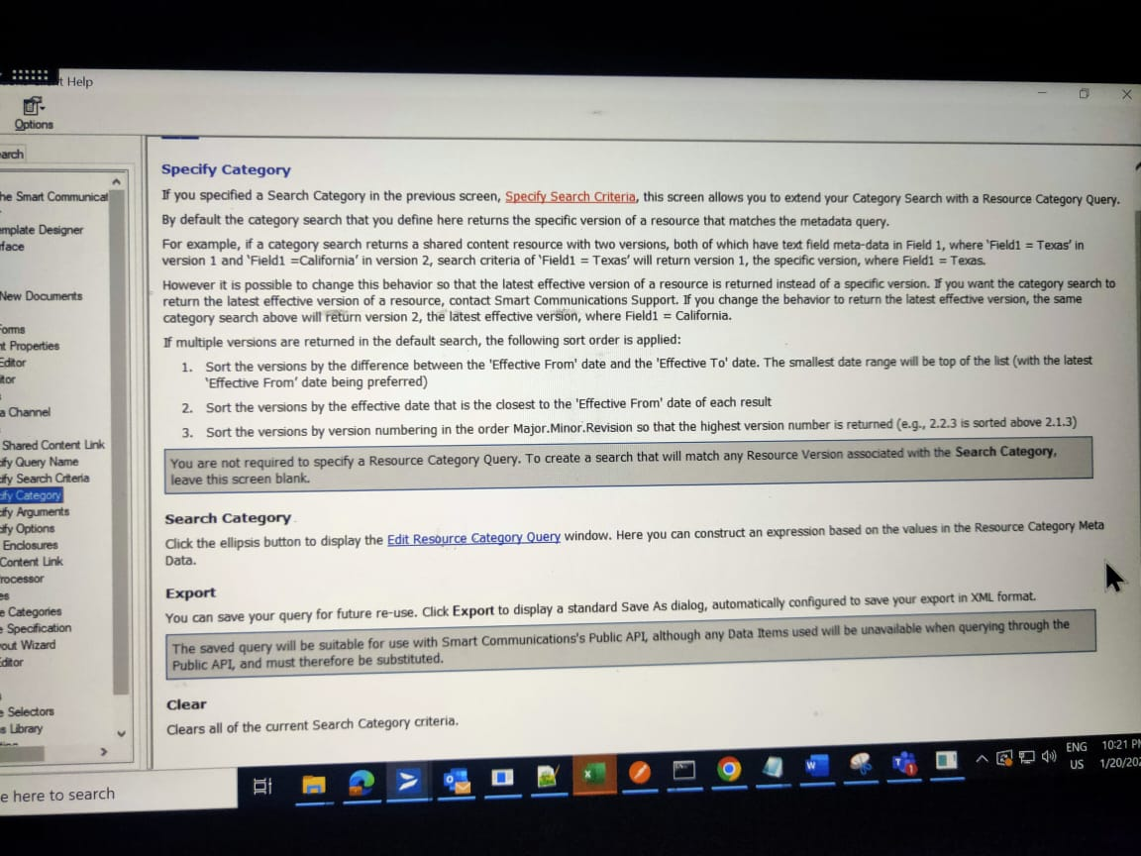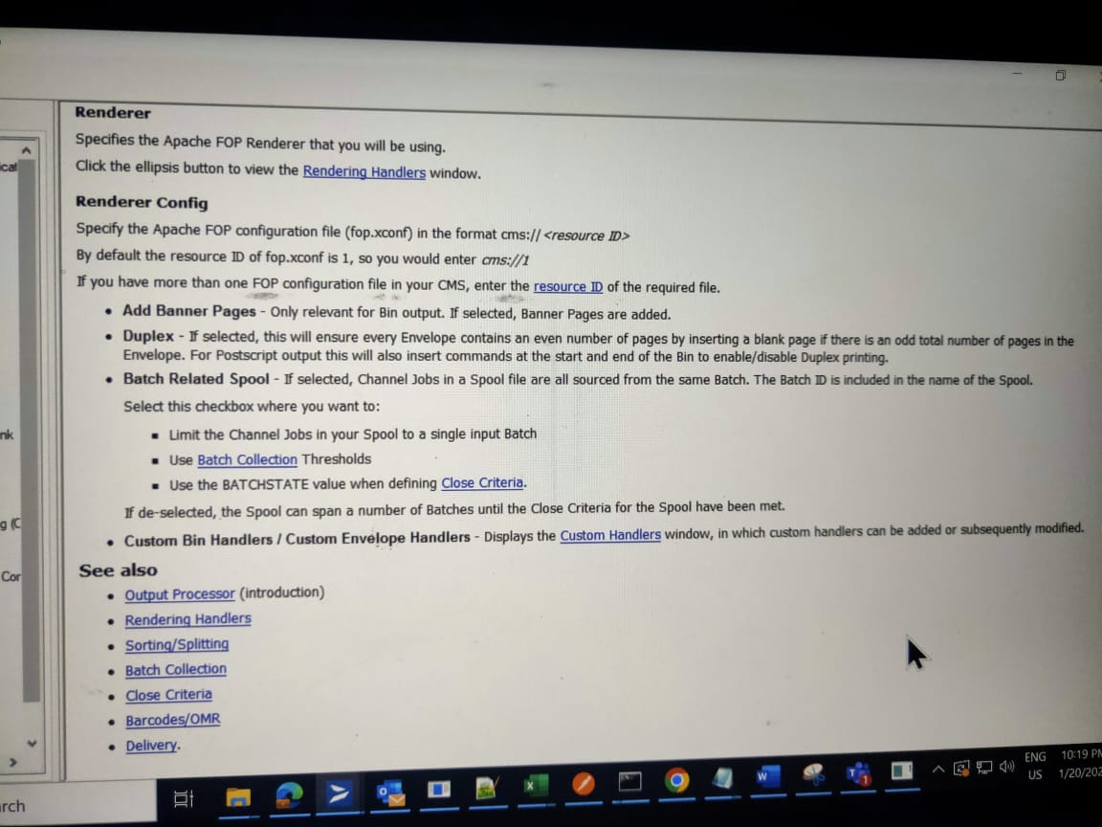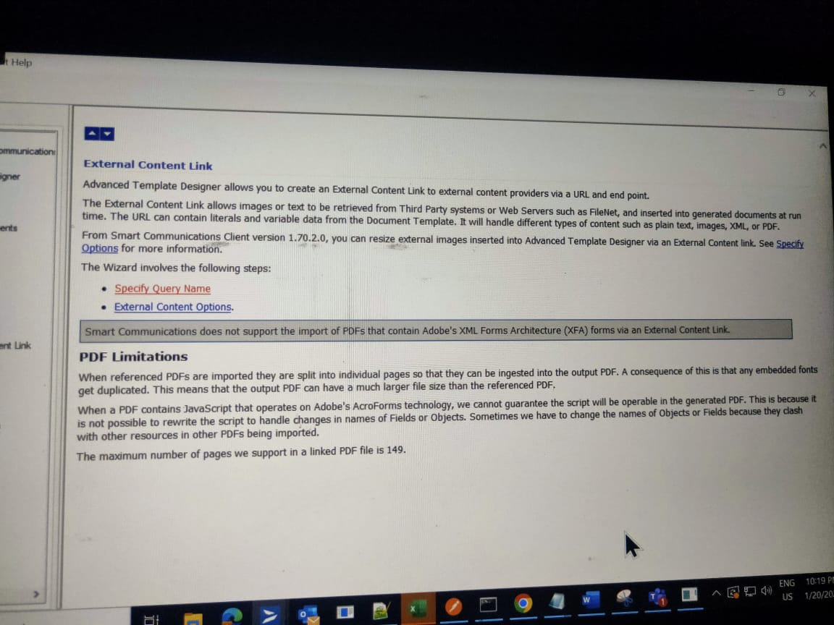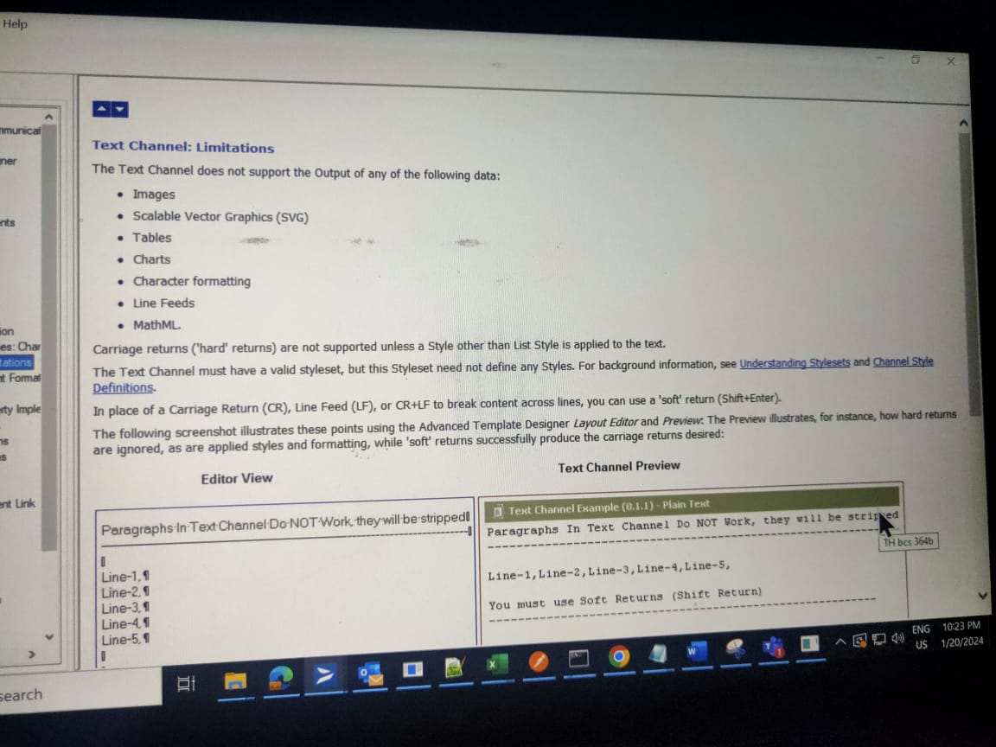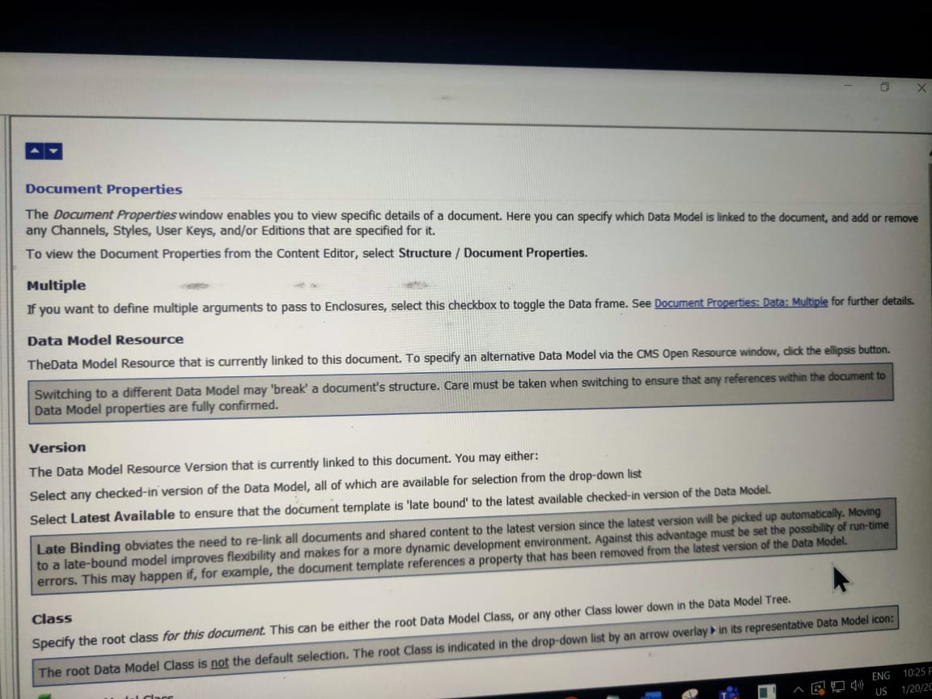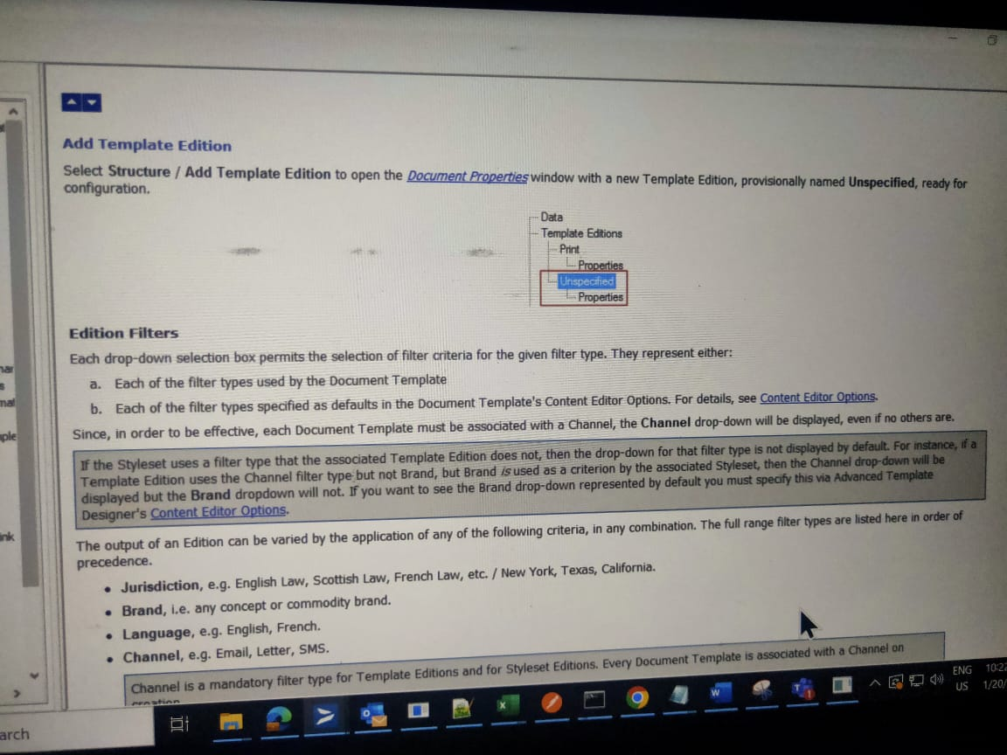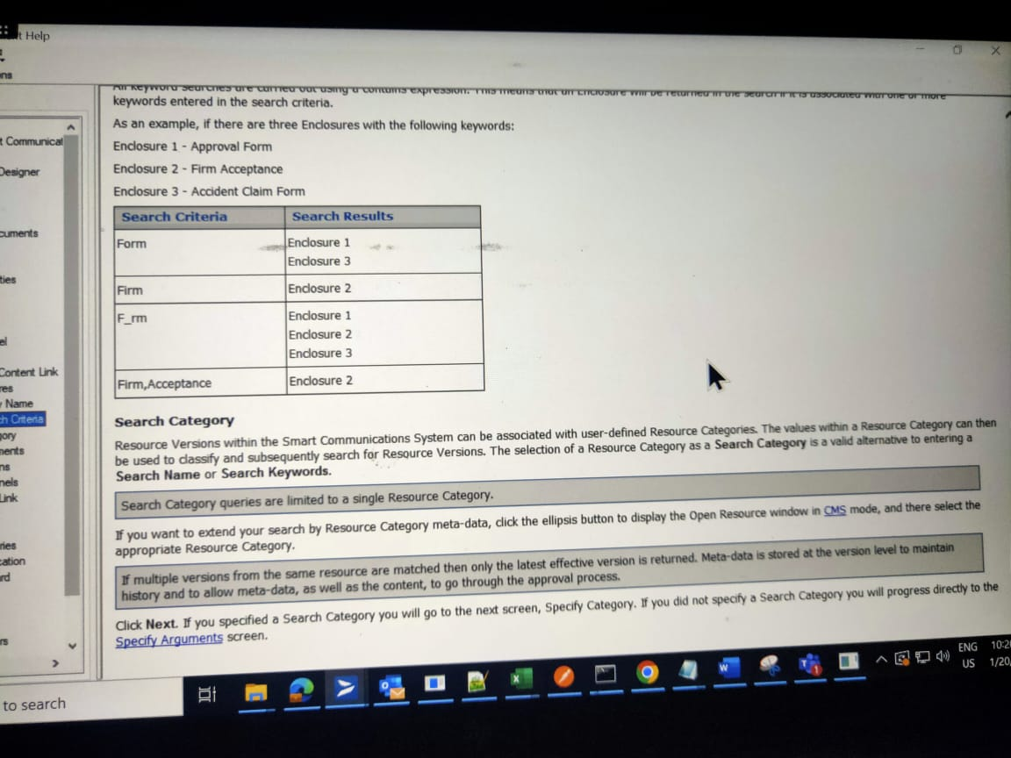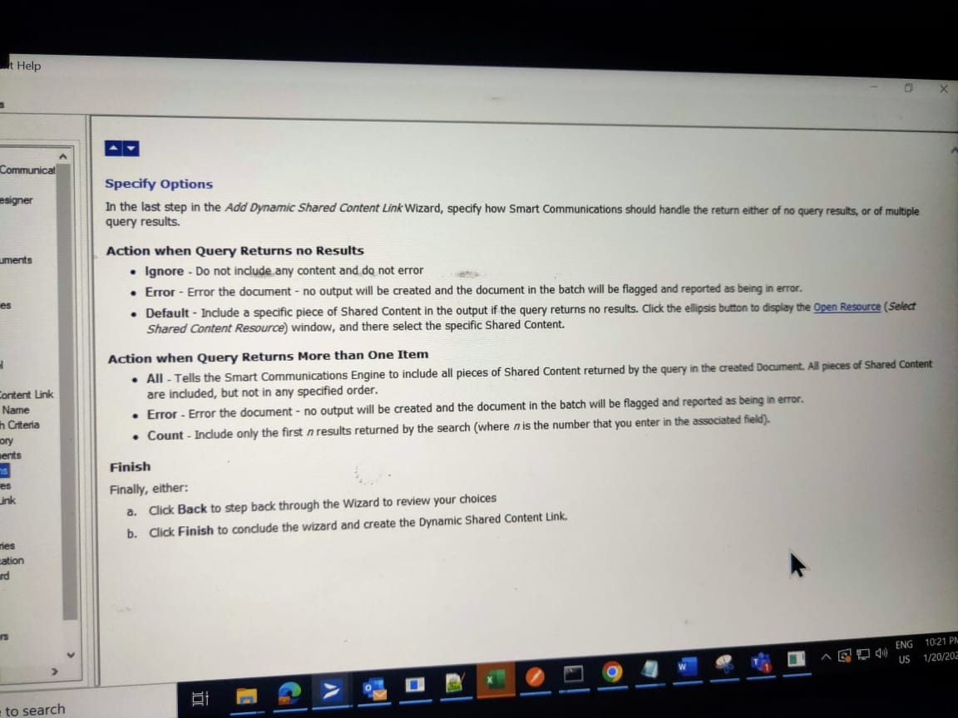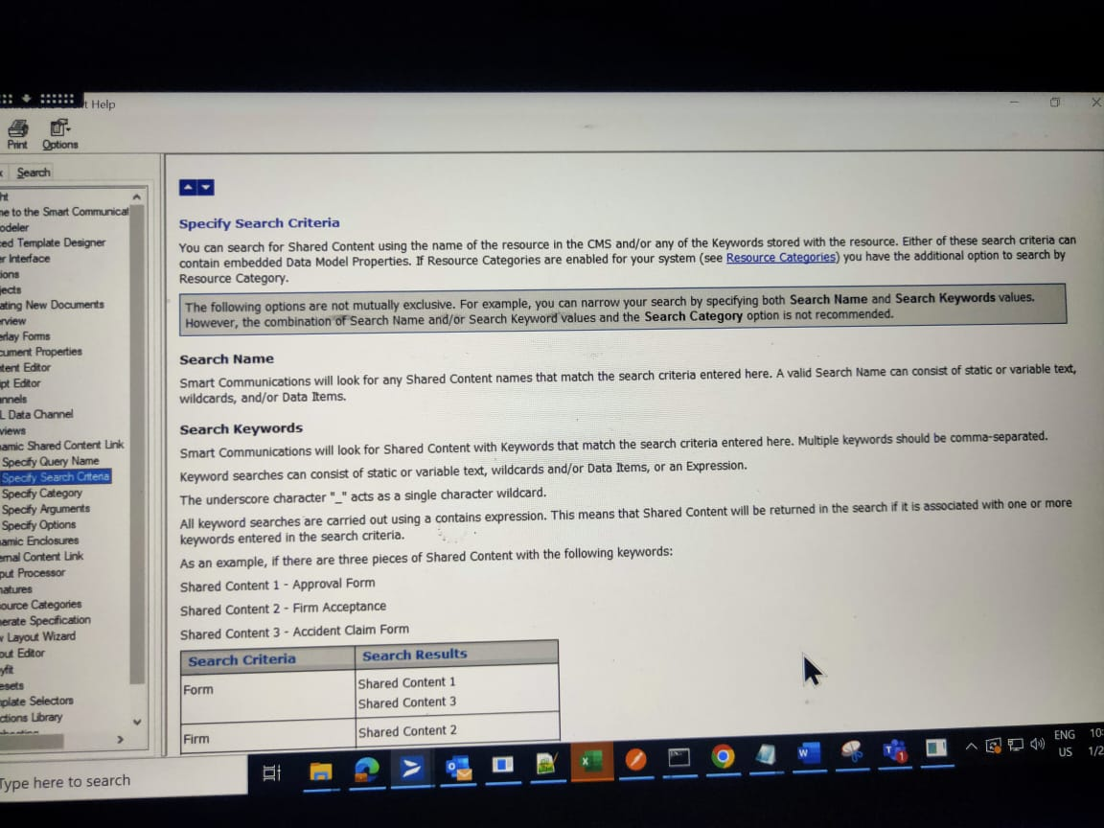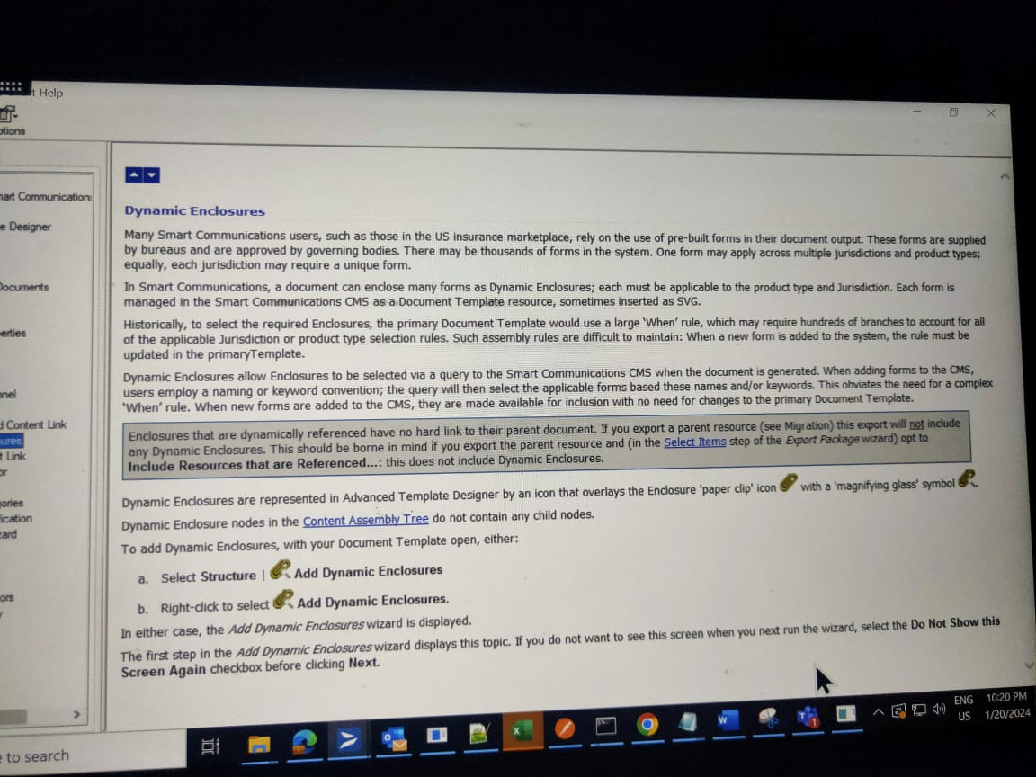

**Barcode:**

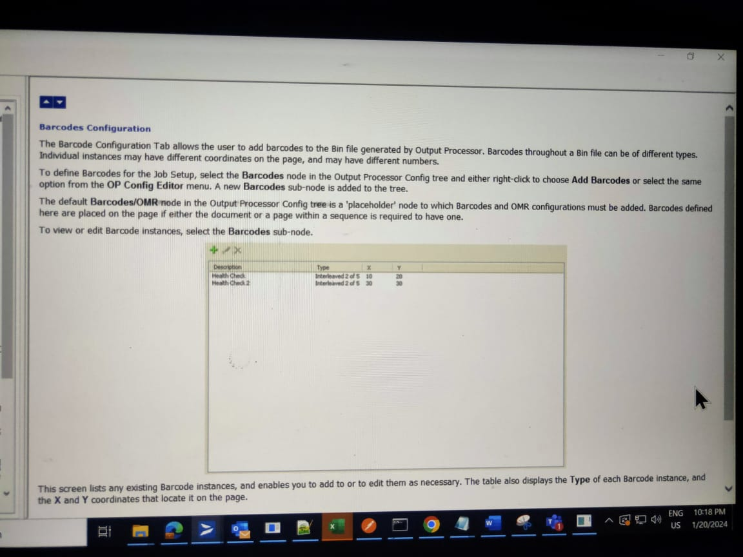

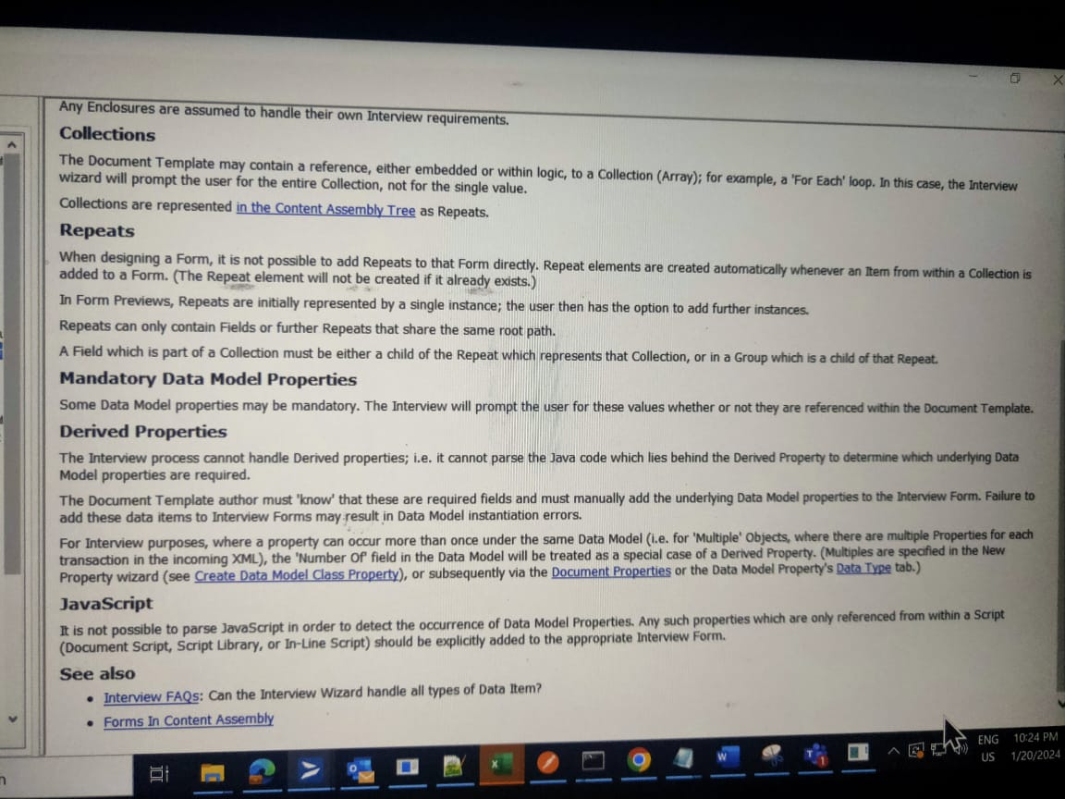

**Output Processor:**

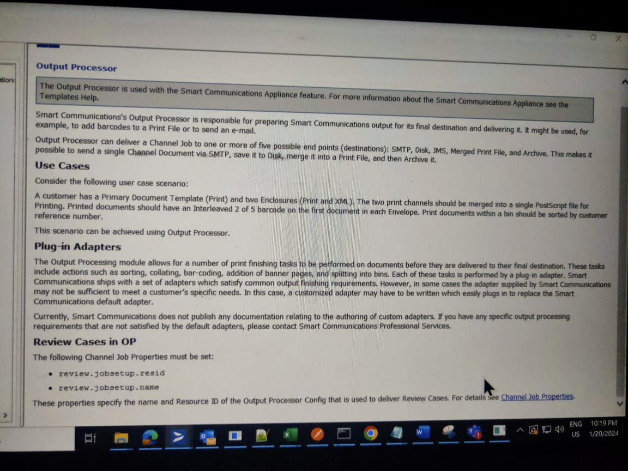

**Overlay:**

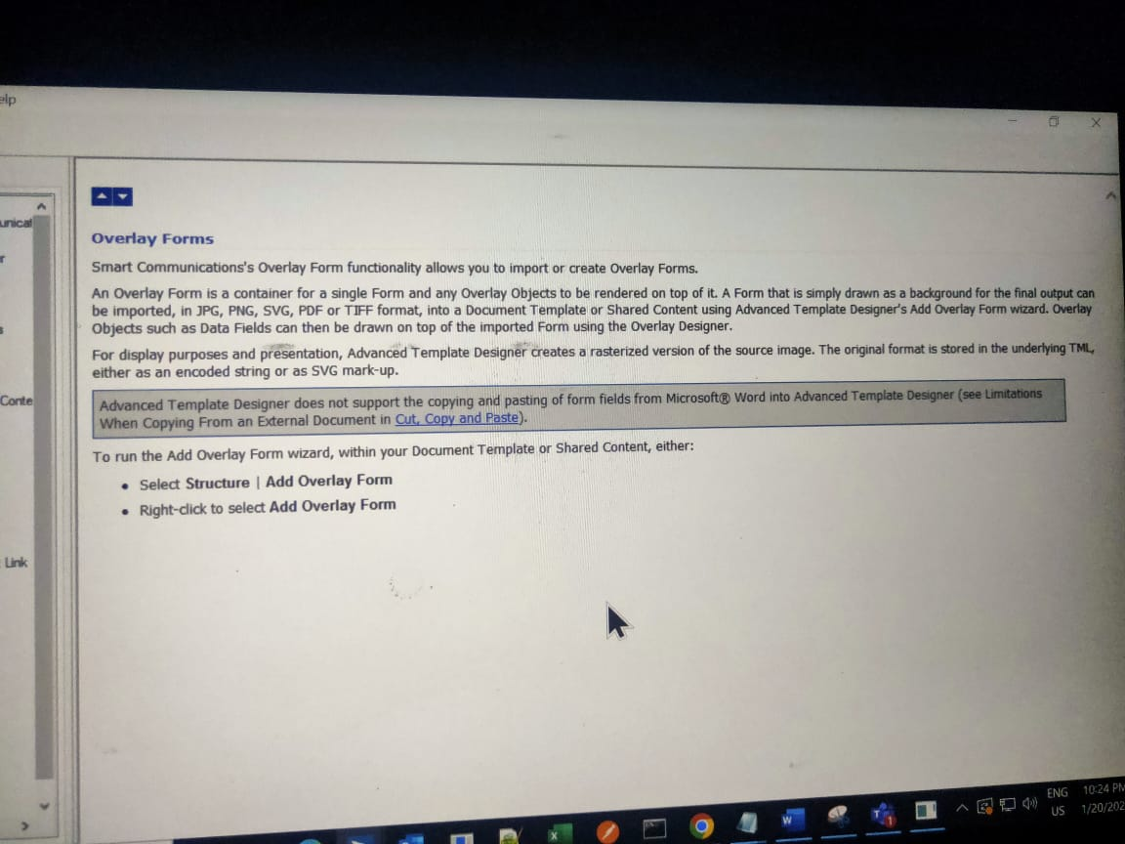

**Data Model:**

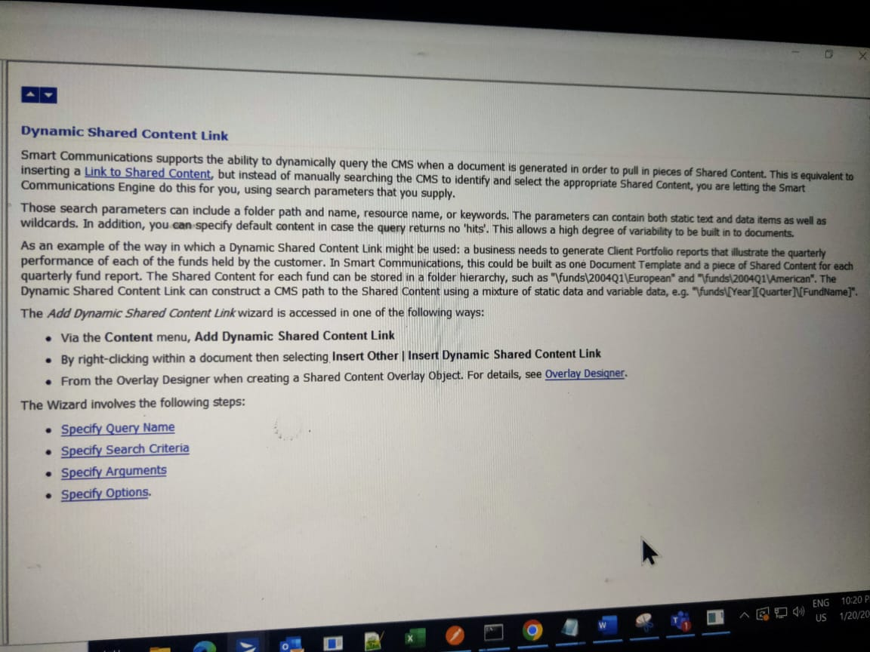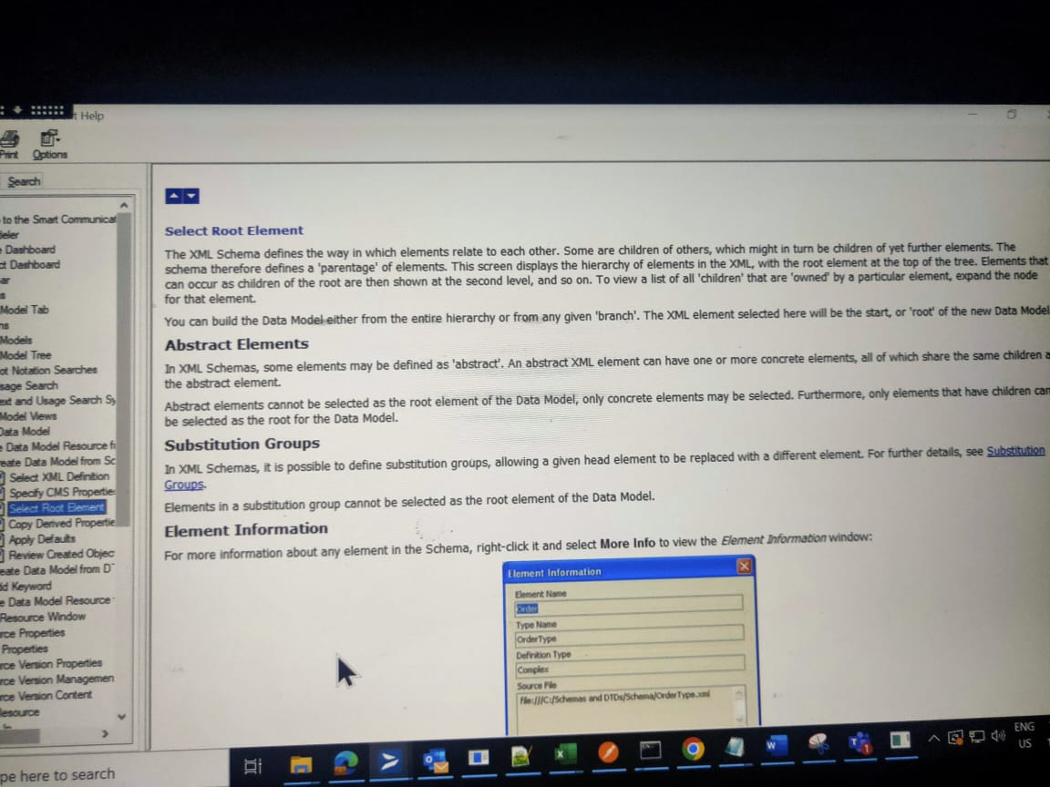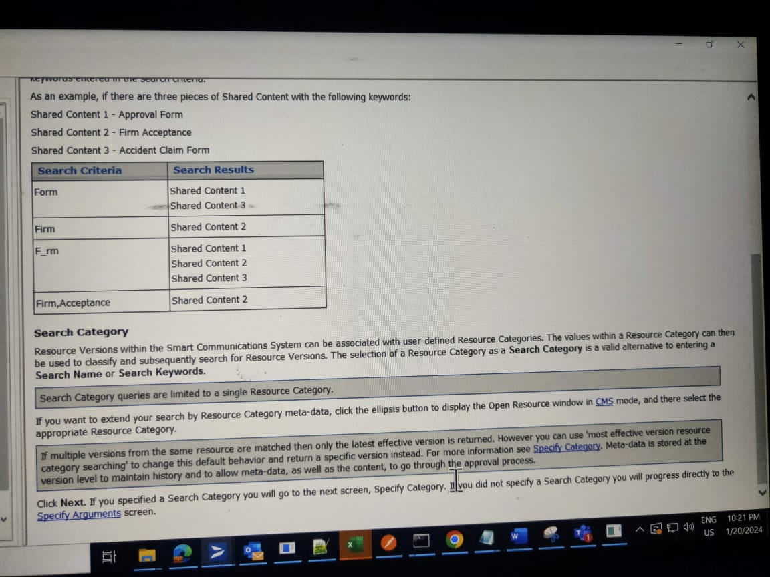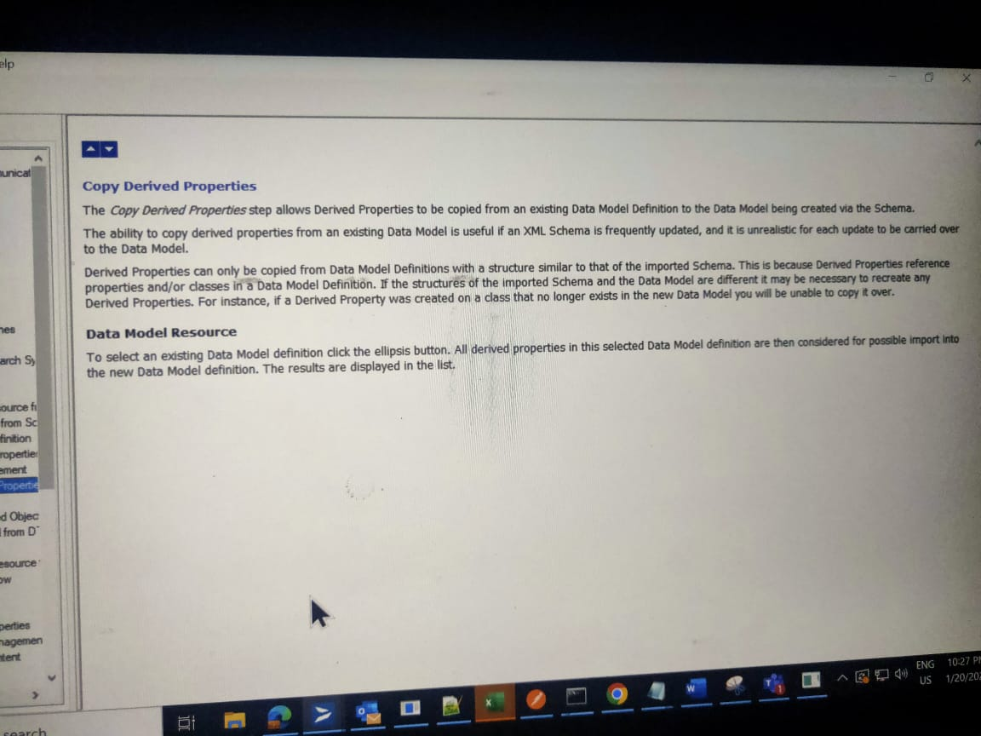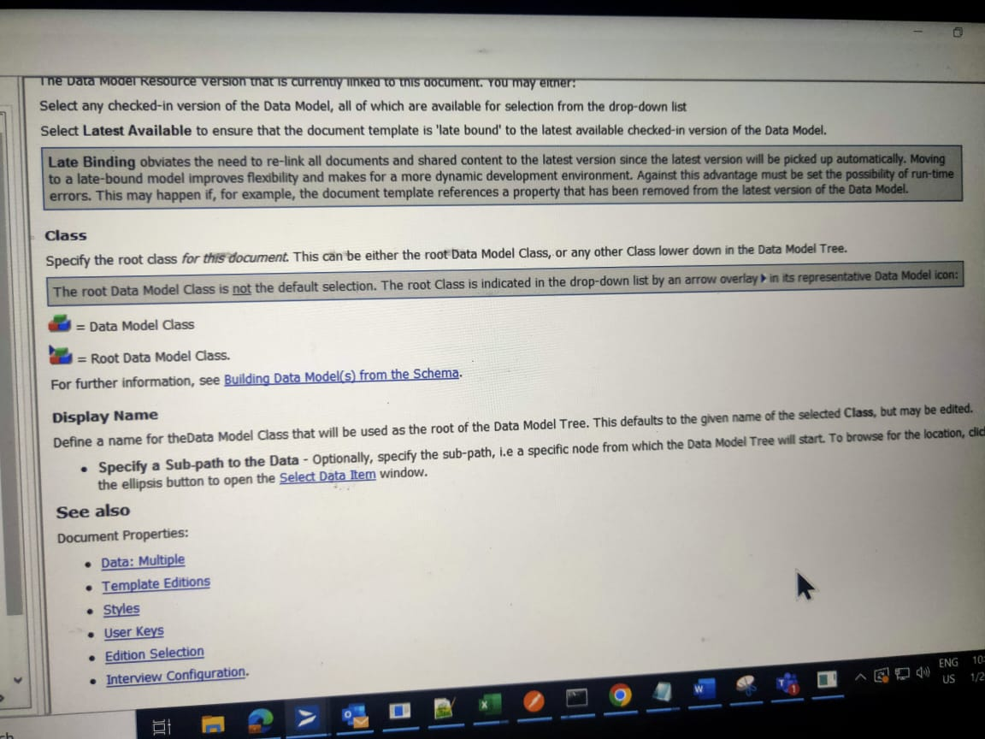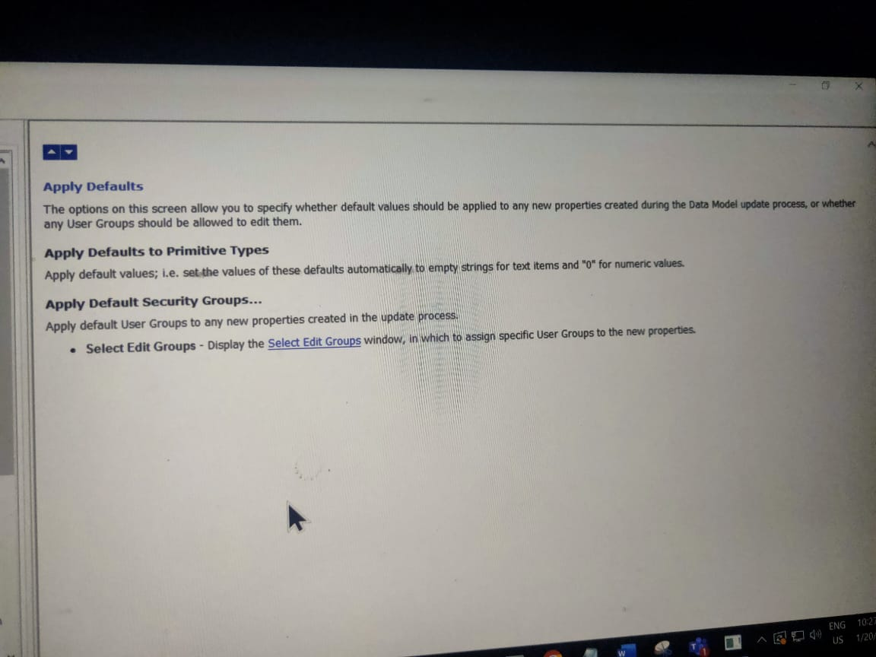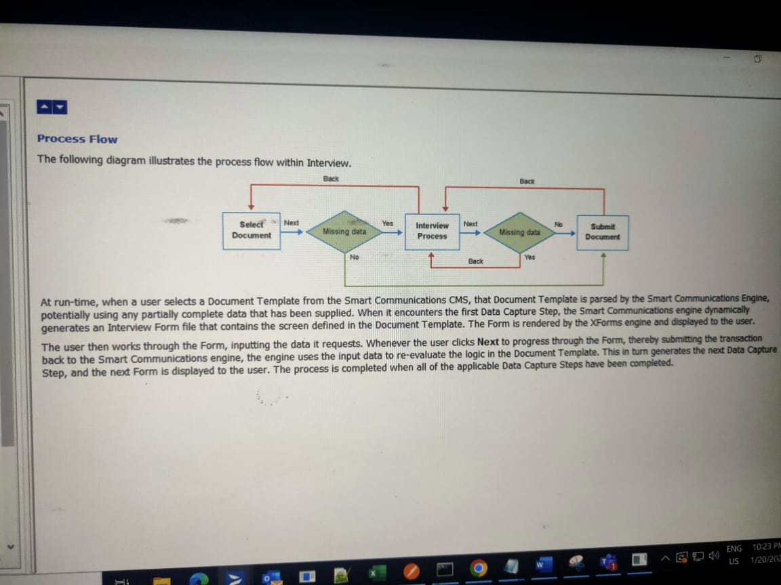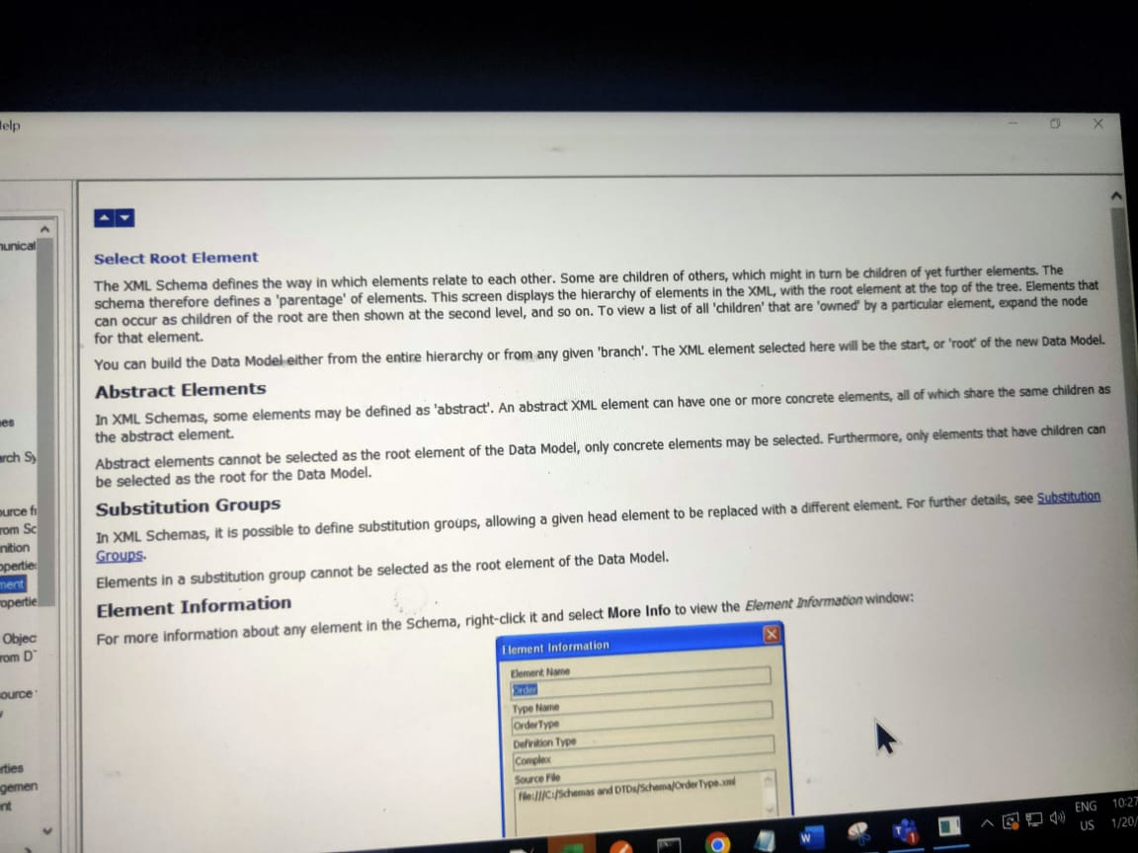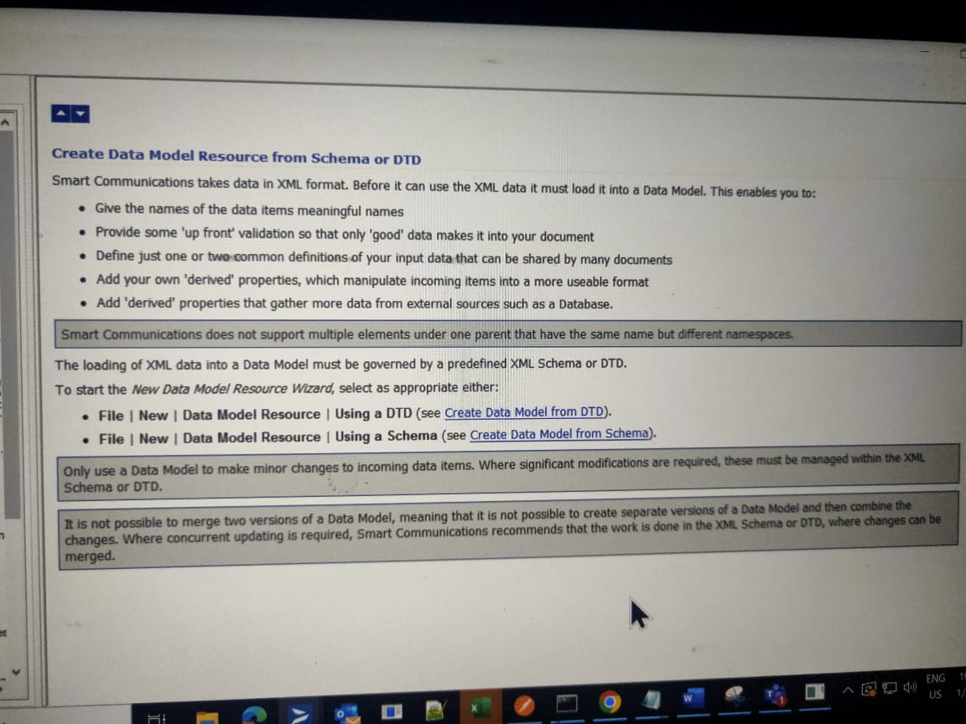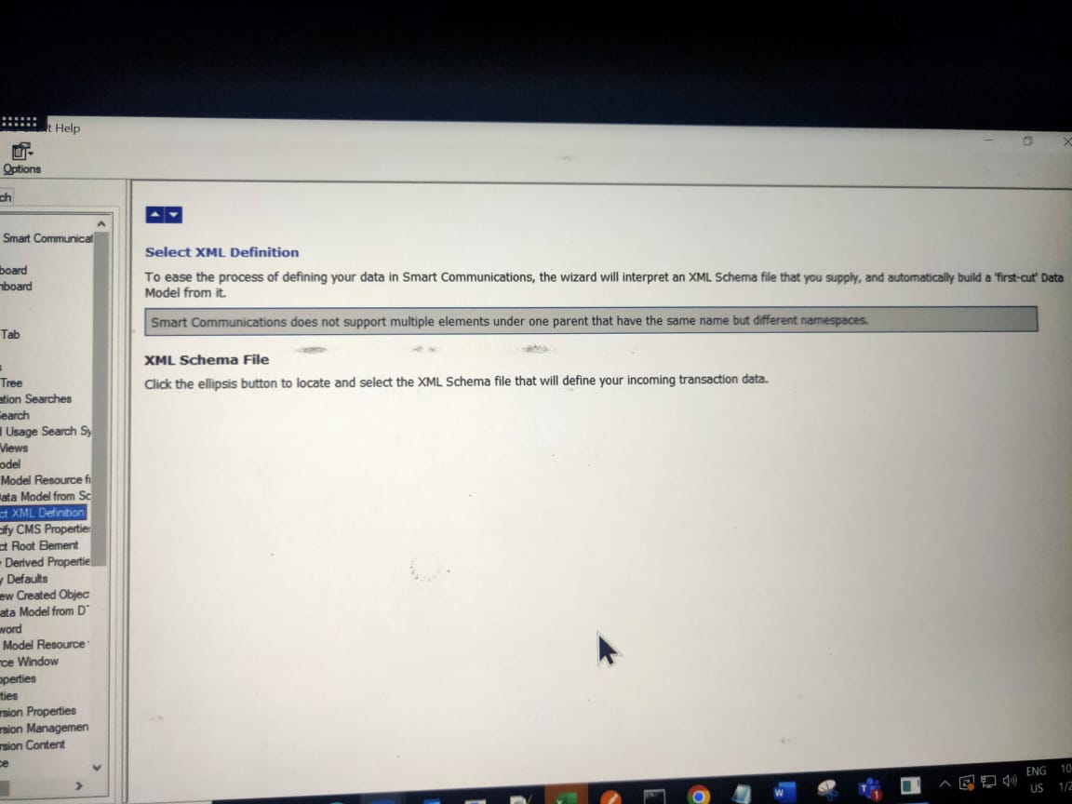

**CMS Property:**

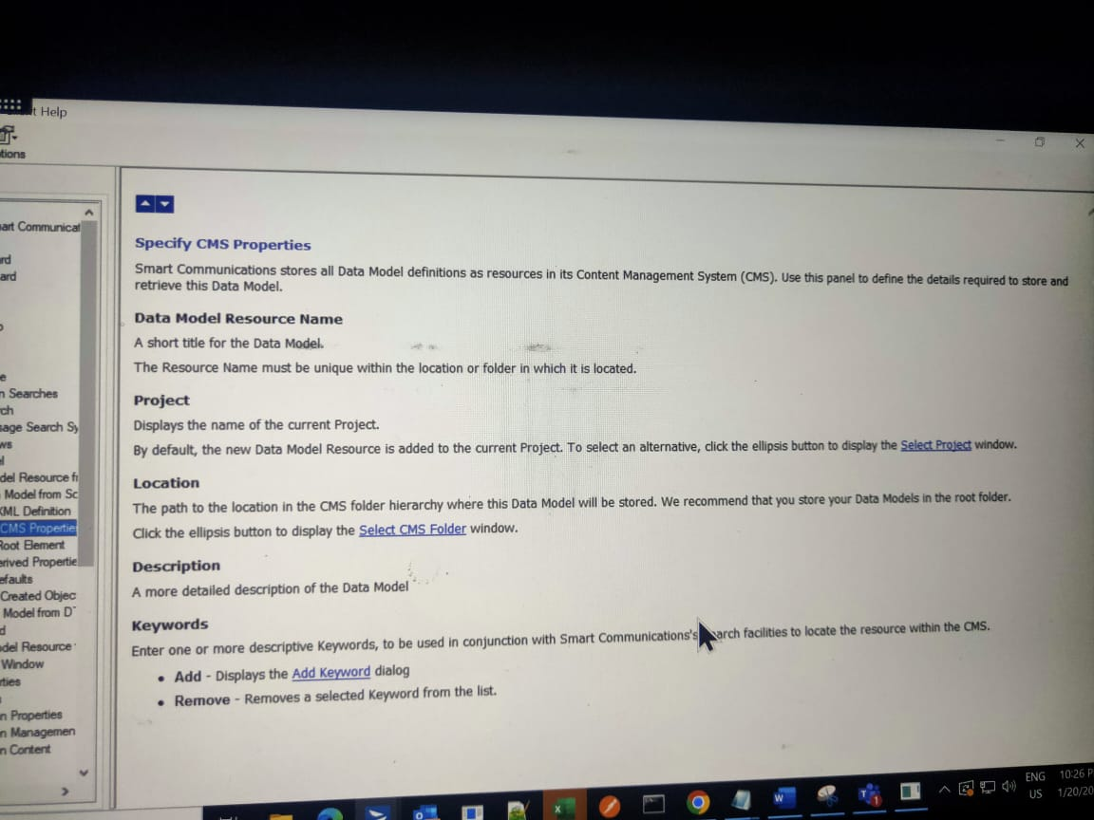

**Derived Property:**

